Out of 8 mid cap find 2

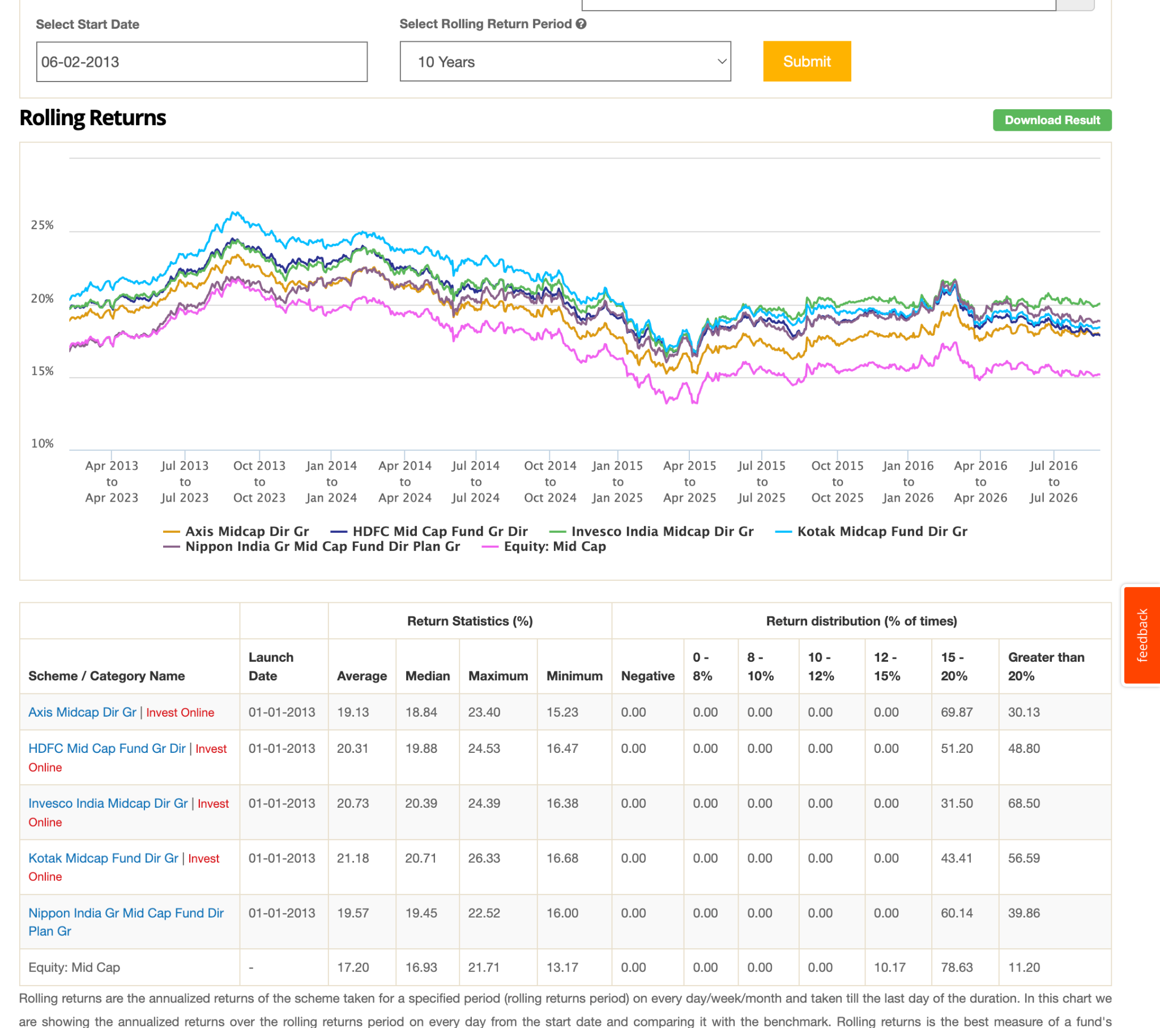
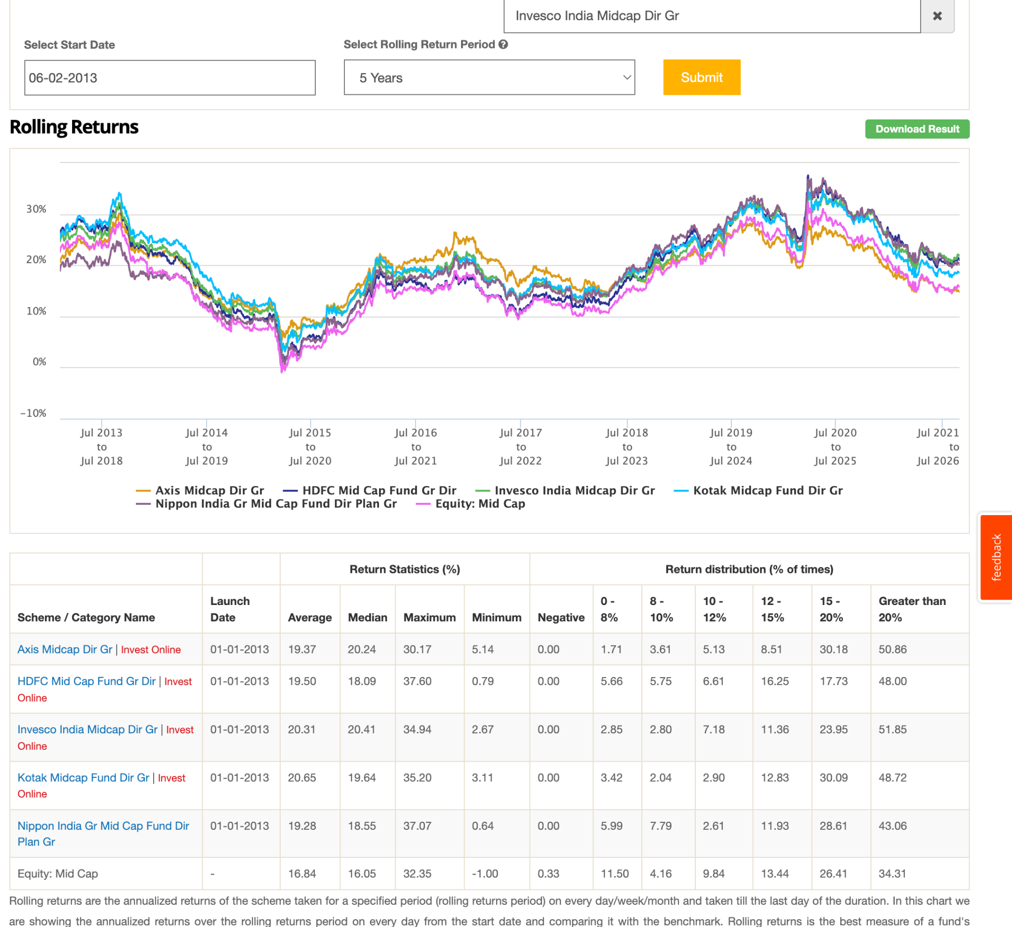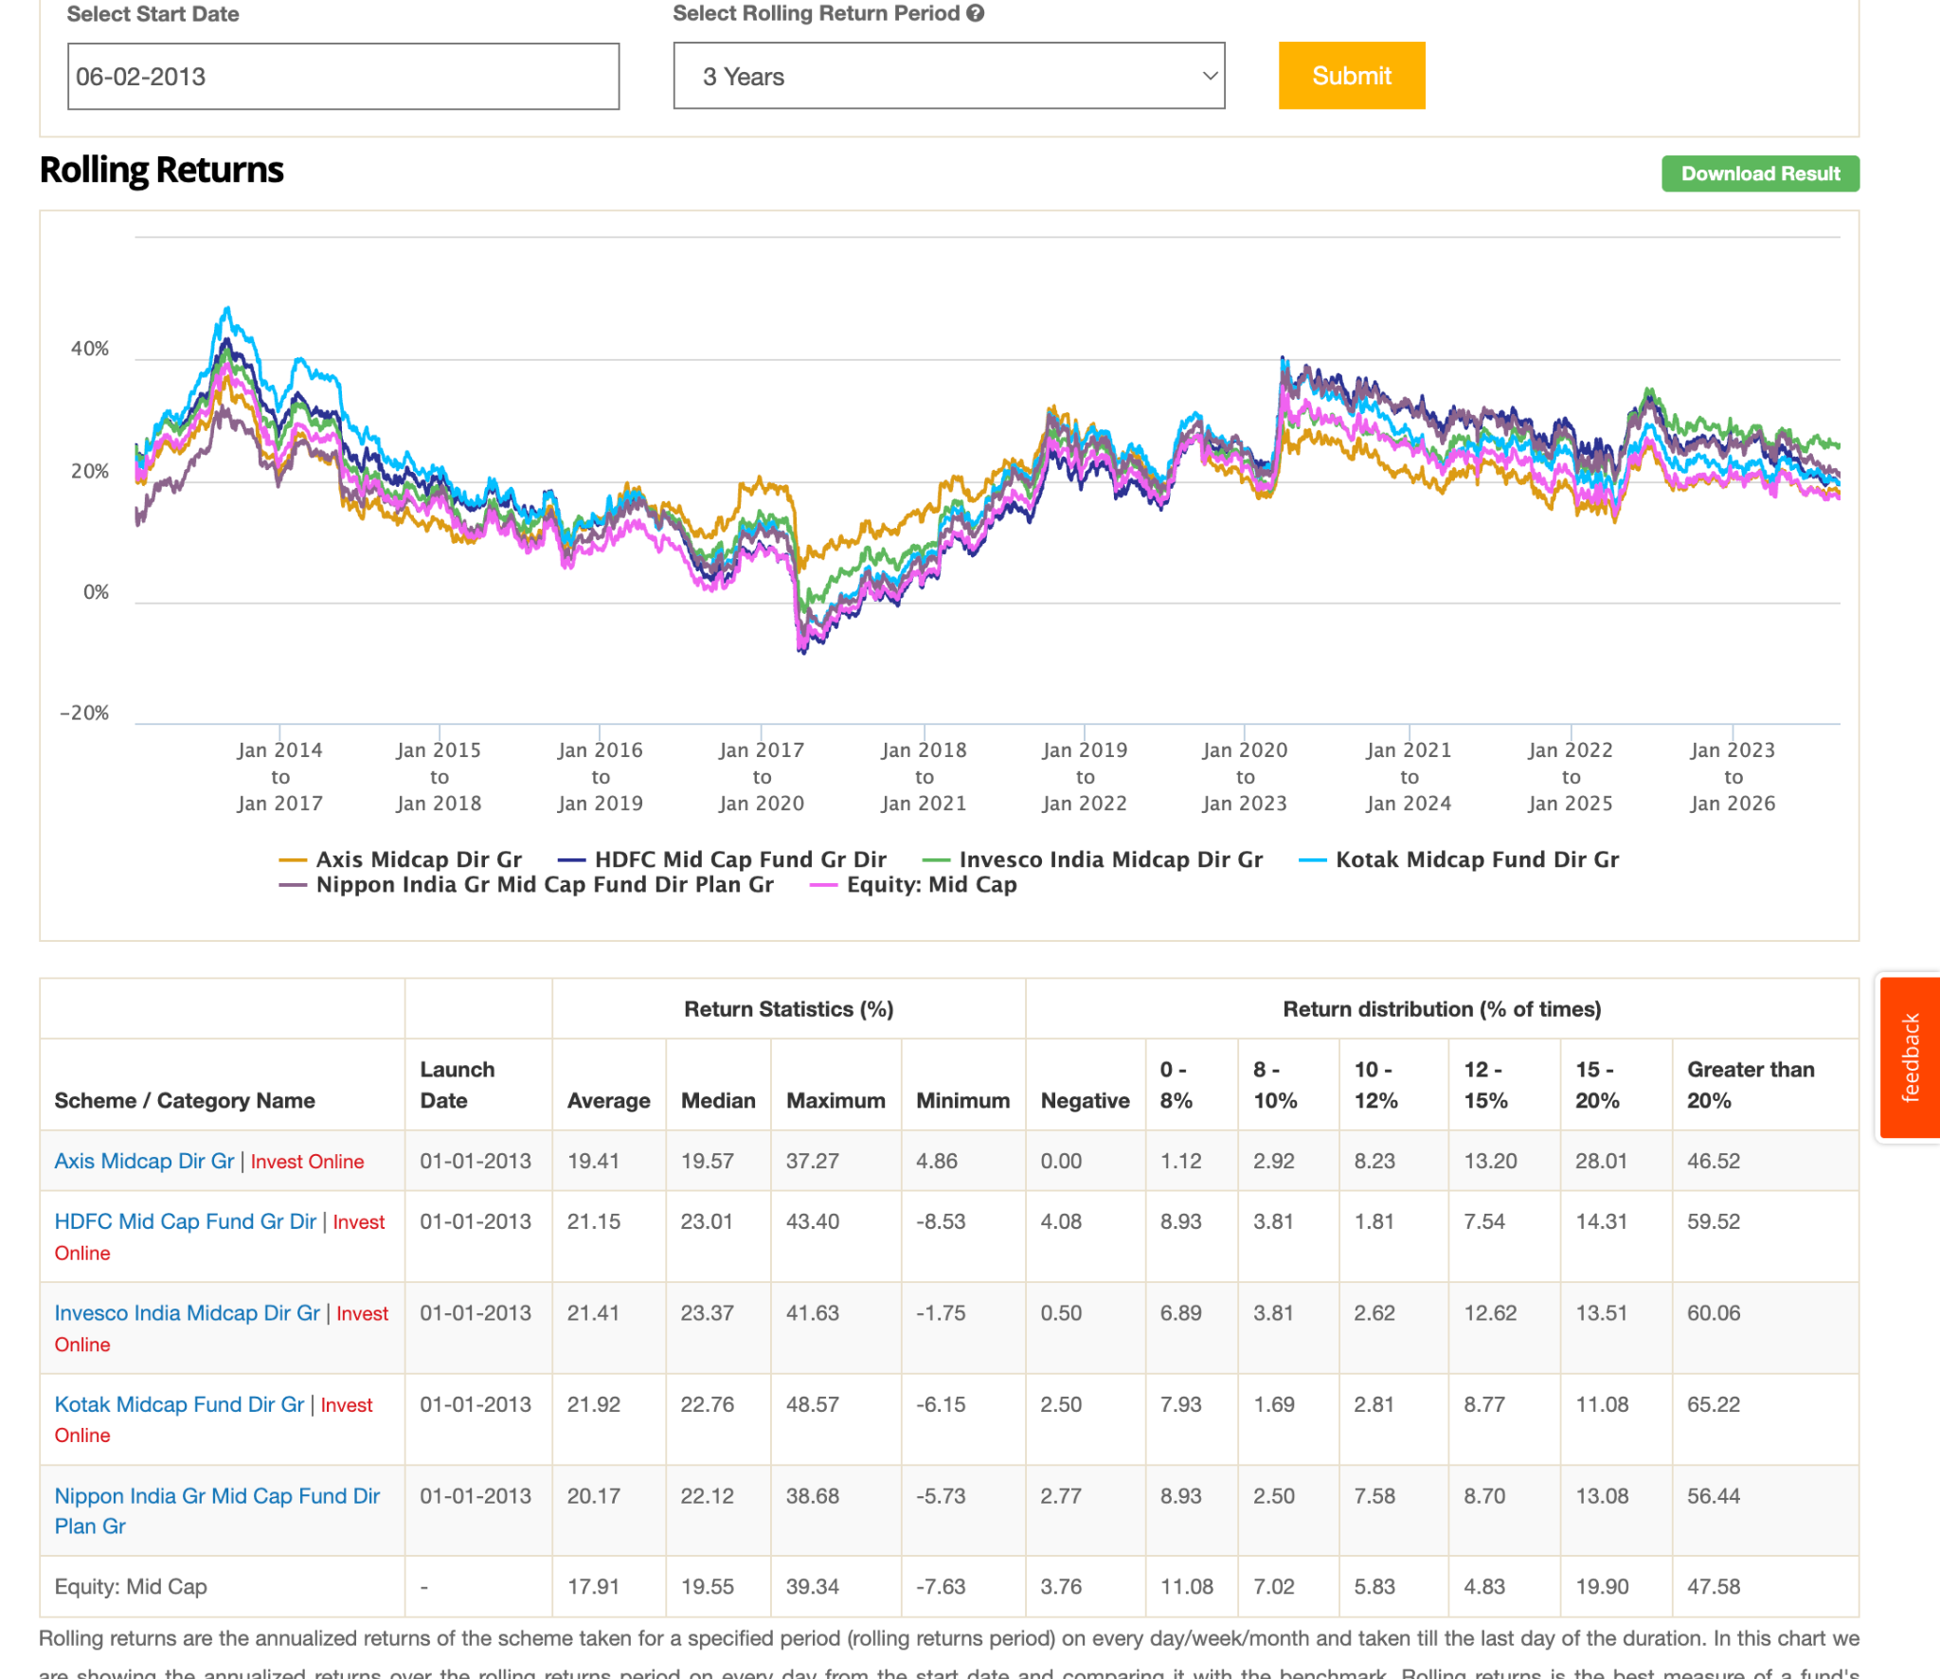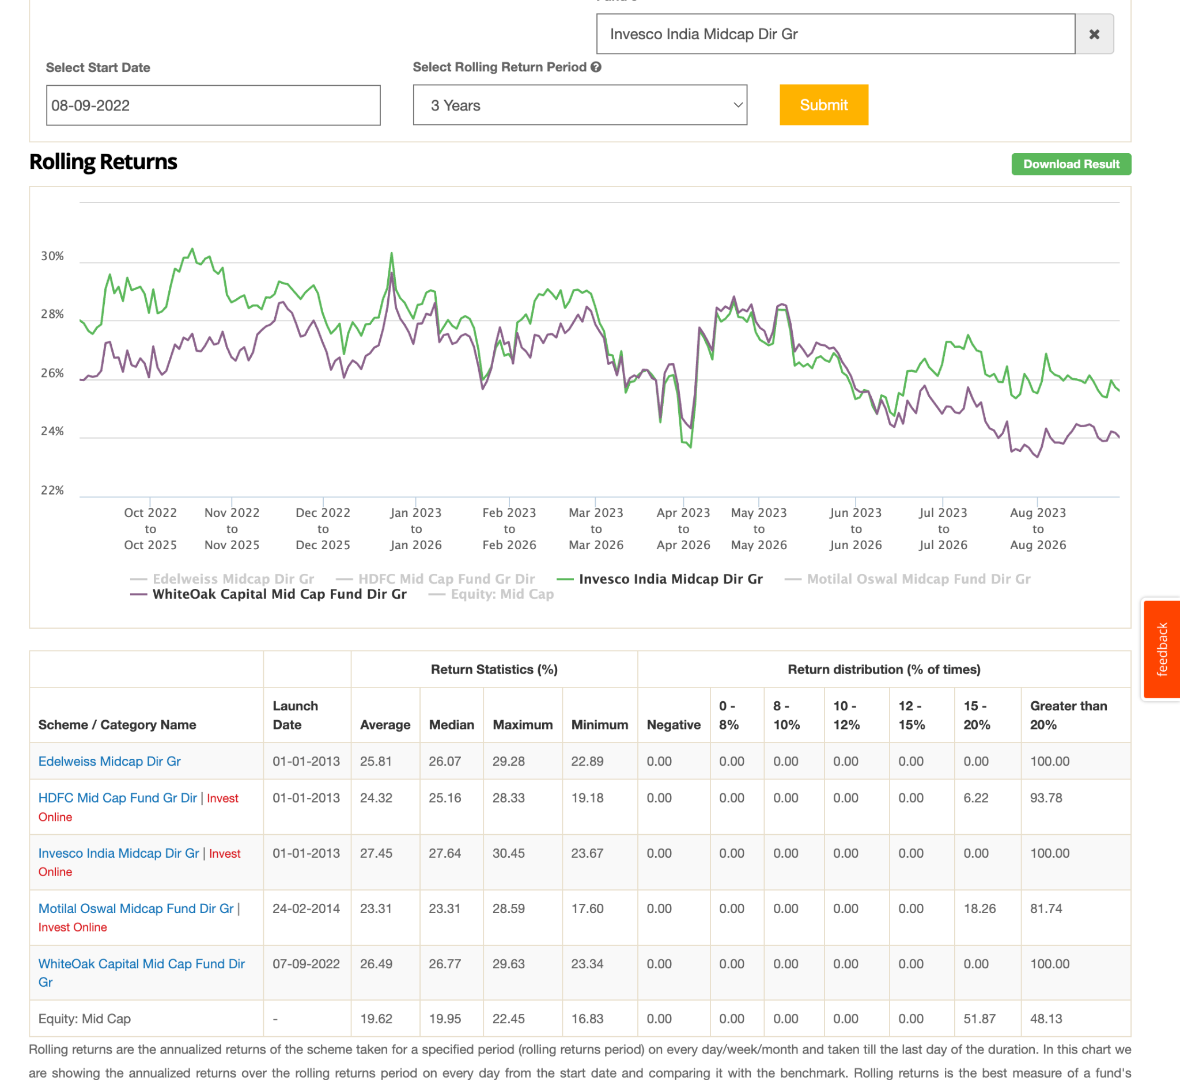
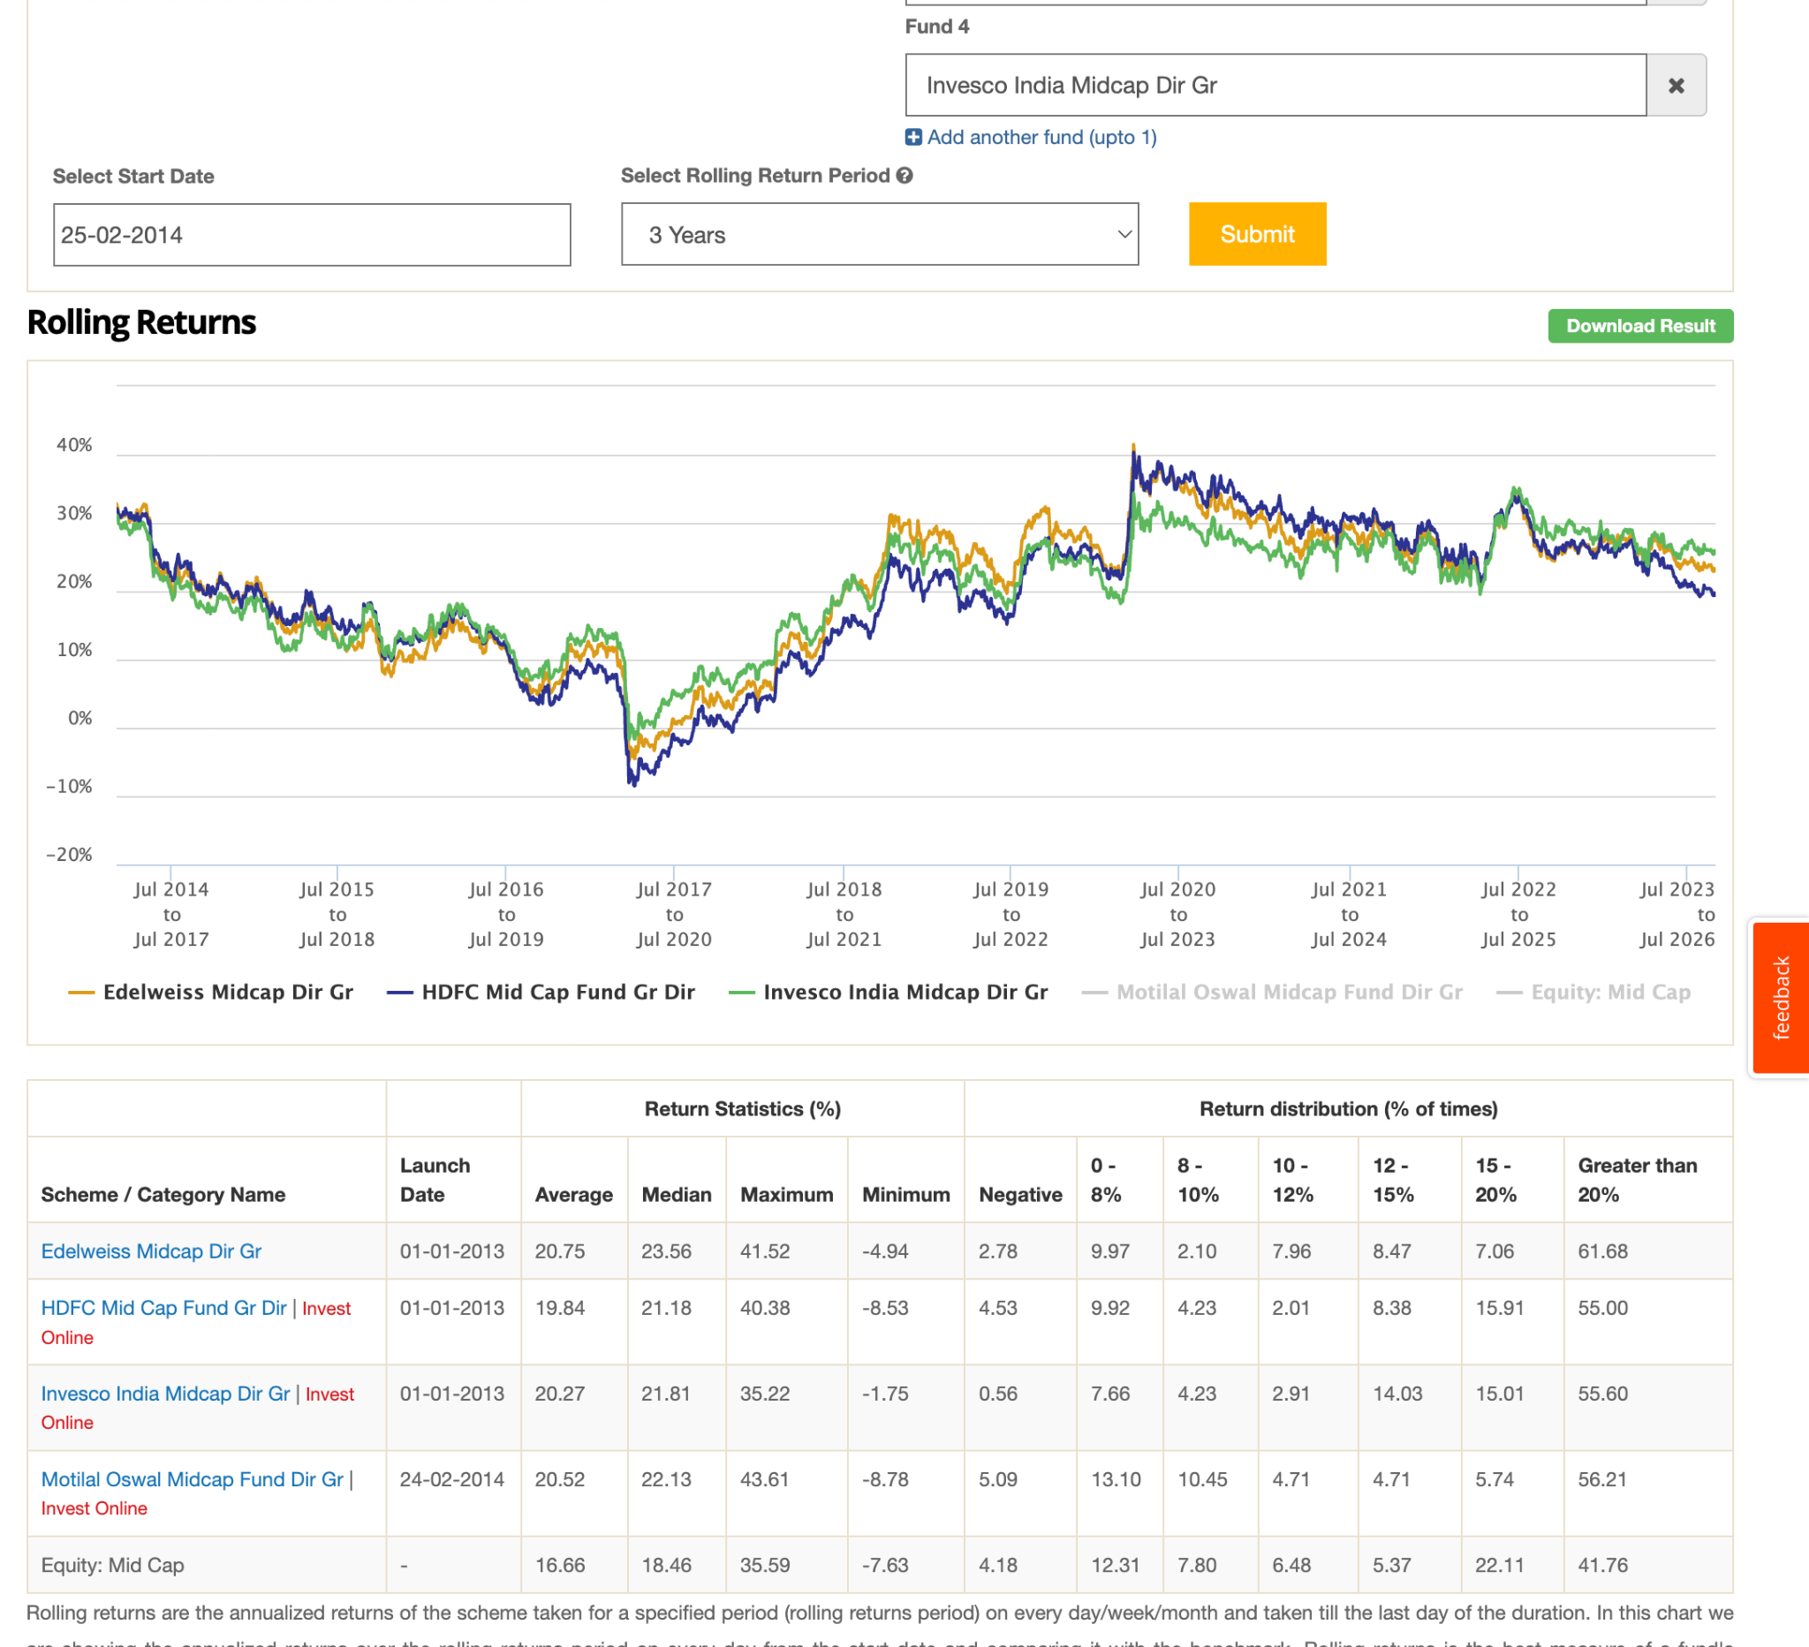
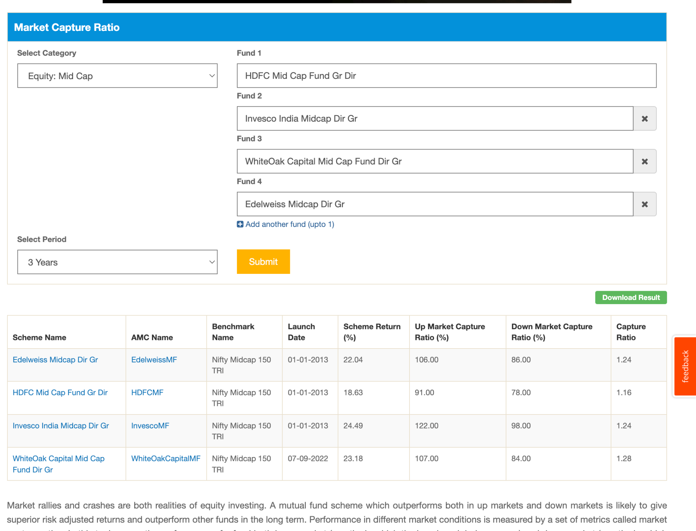
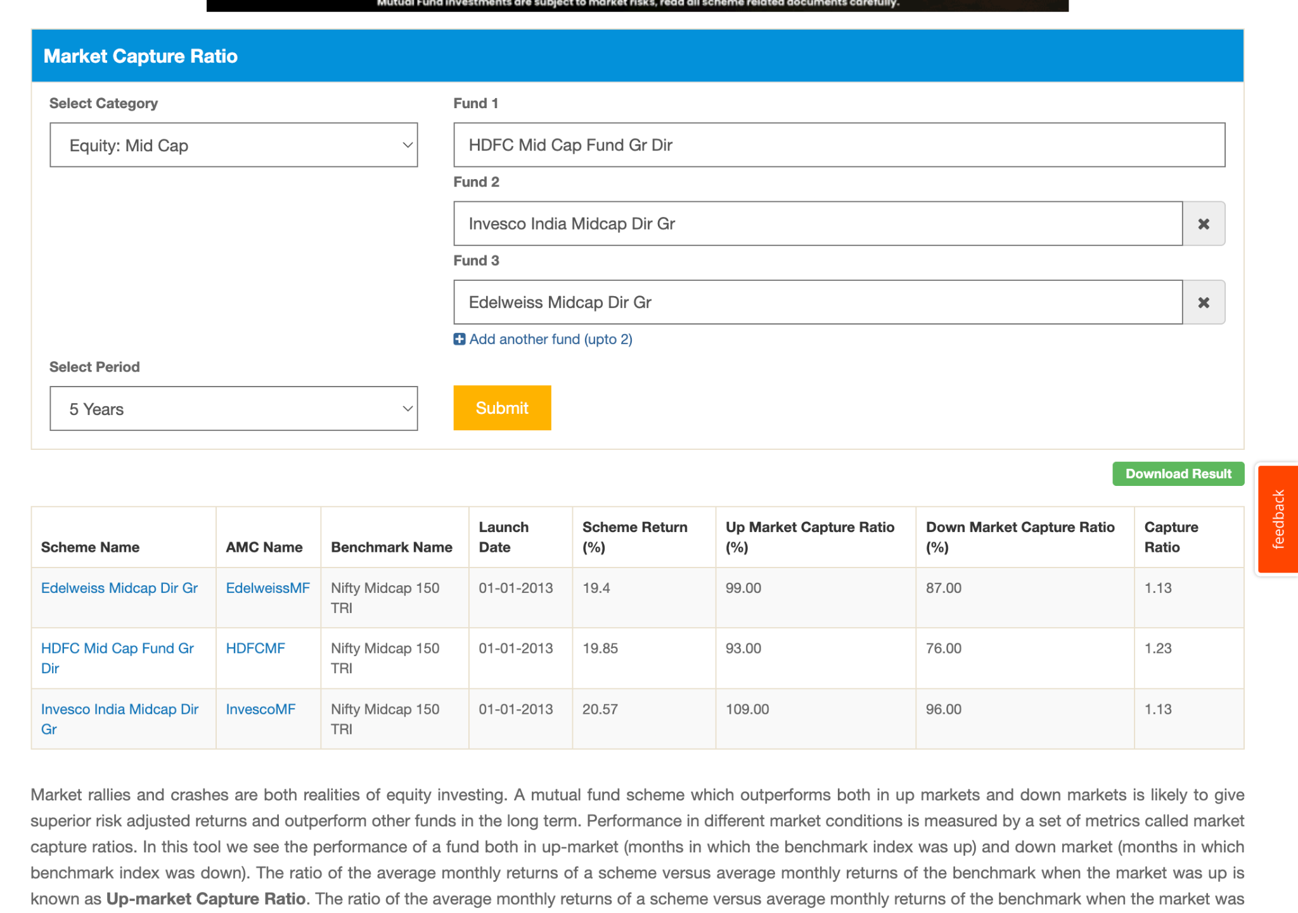
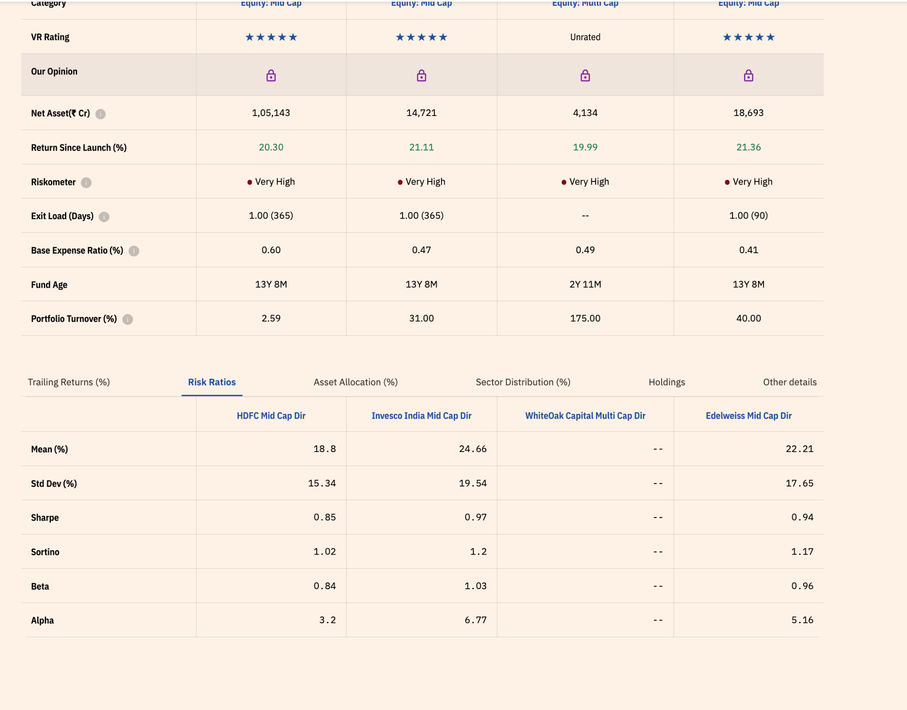
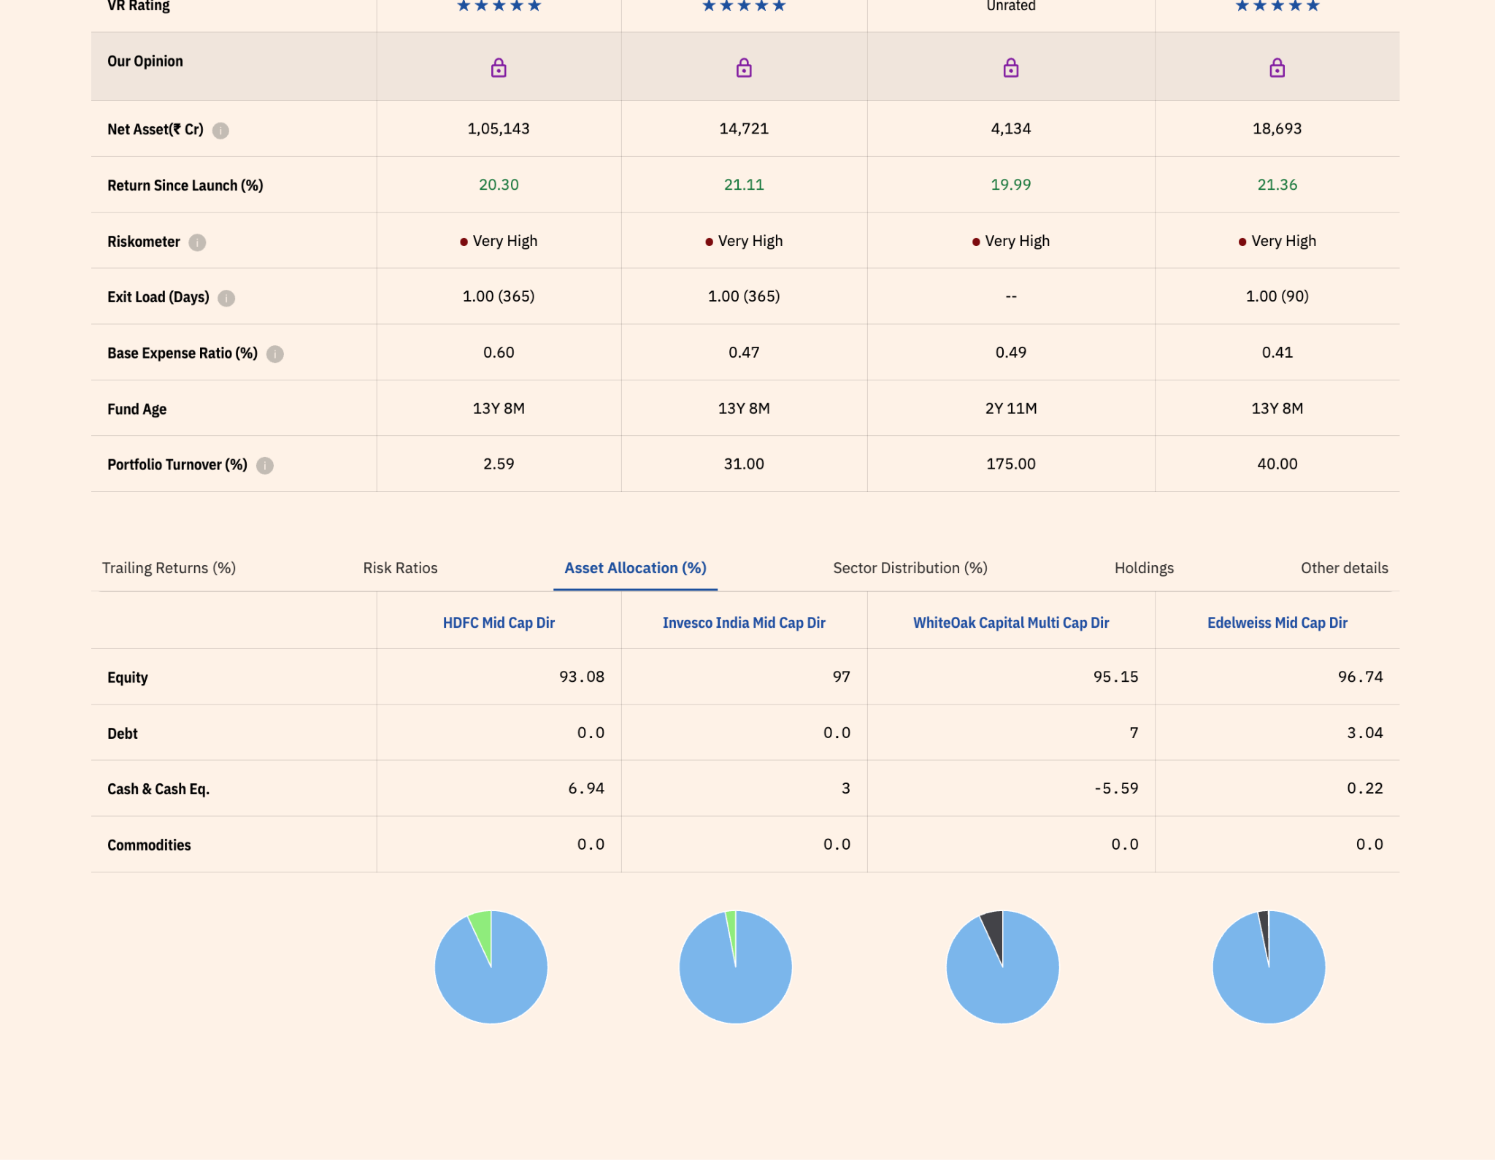
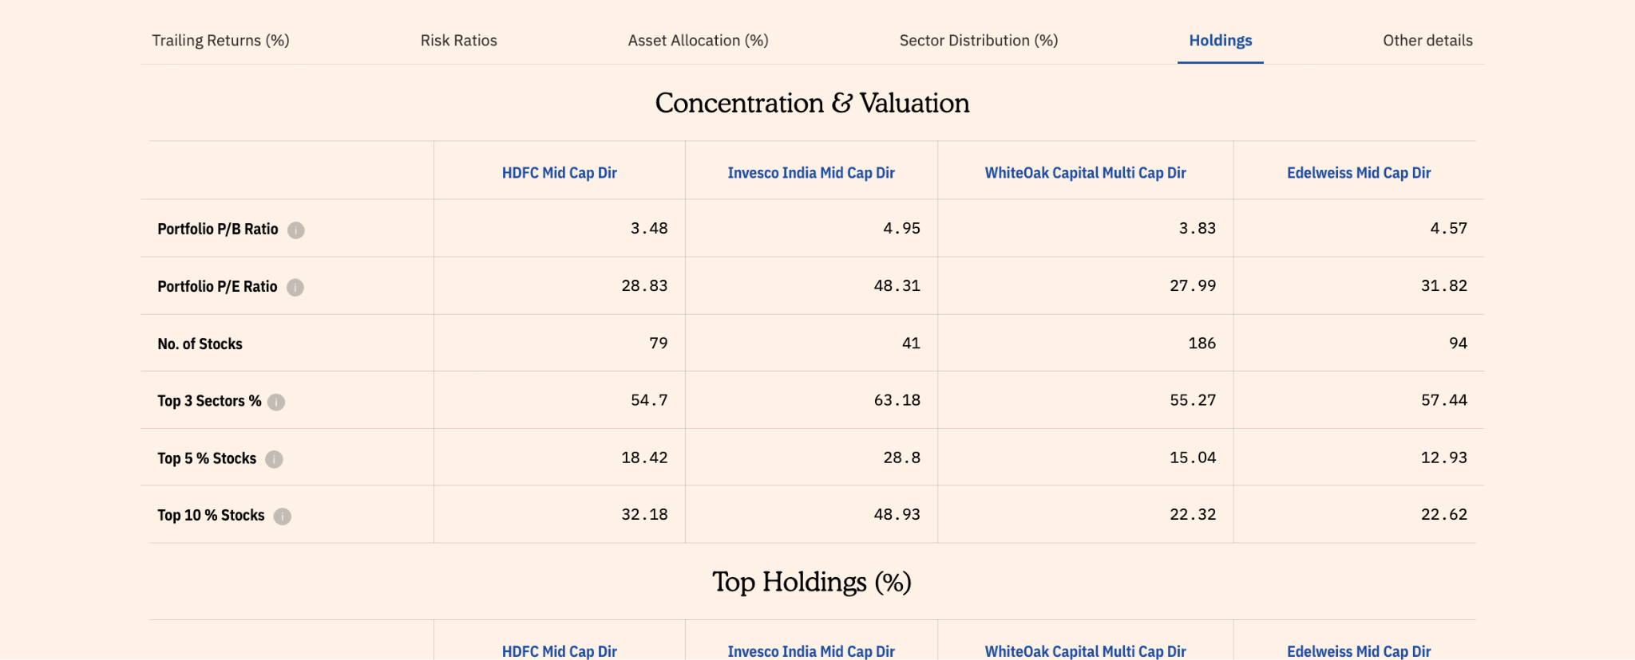
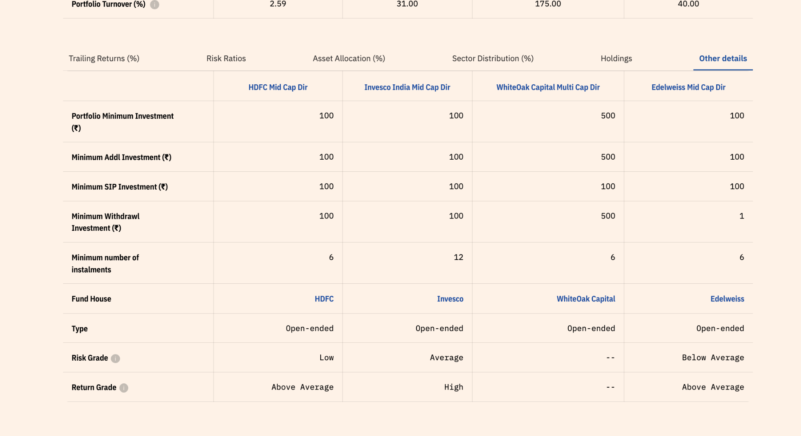
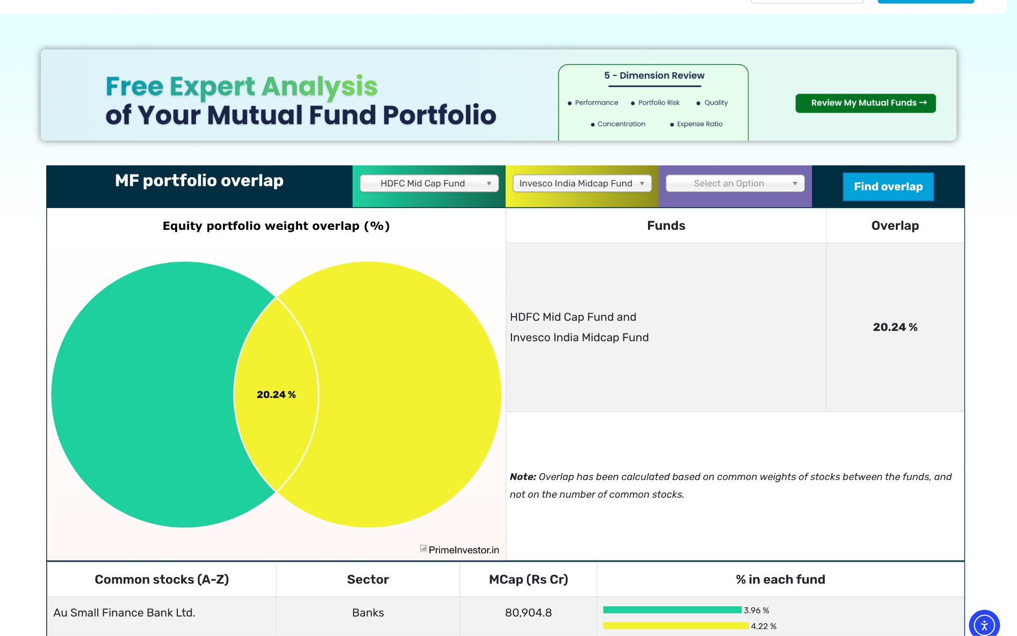
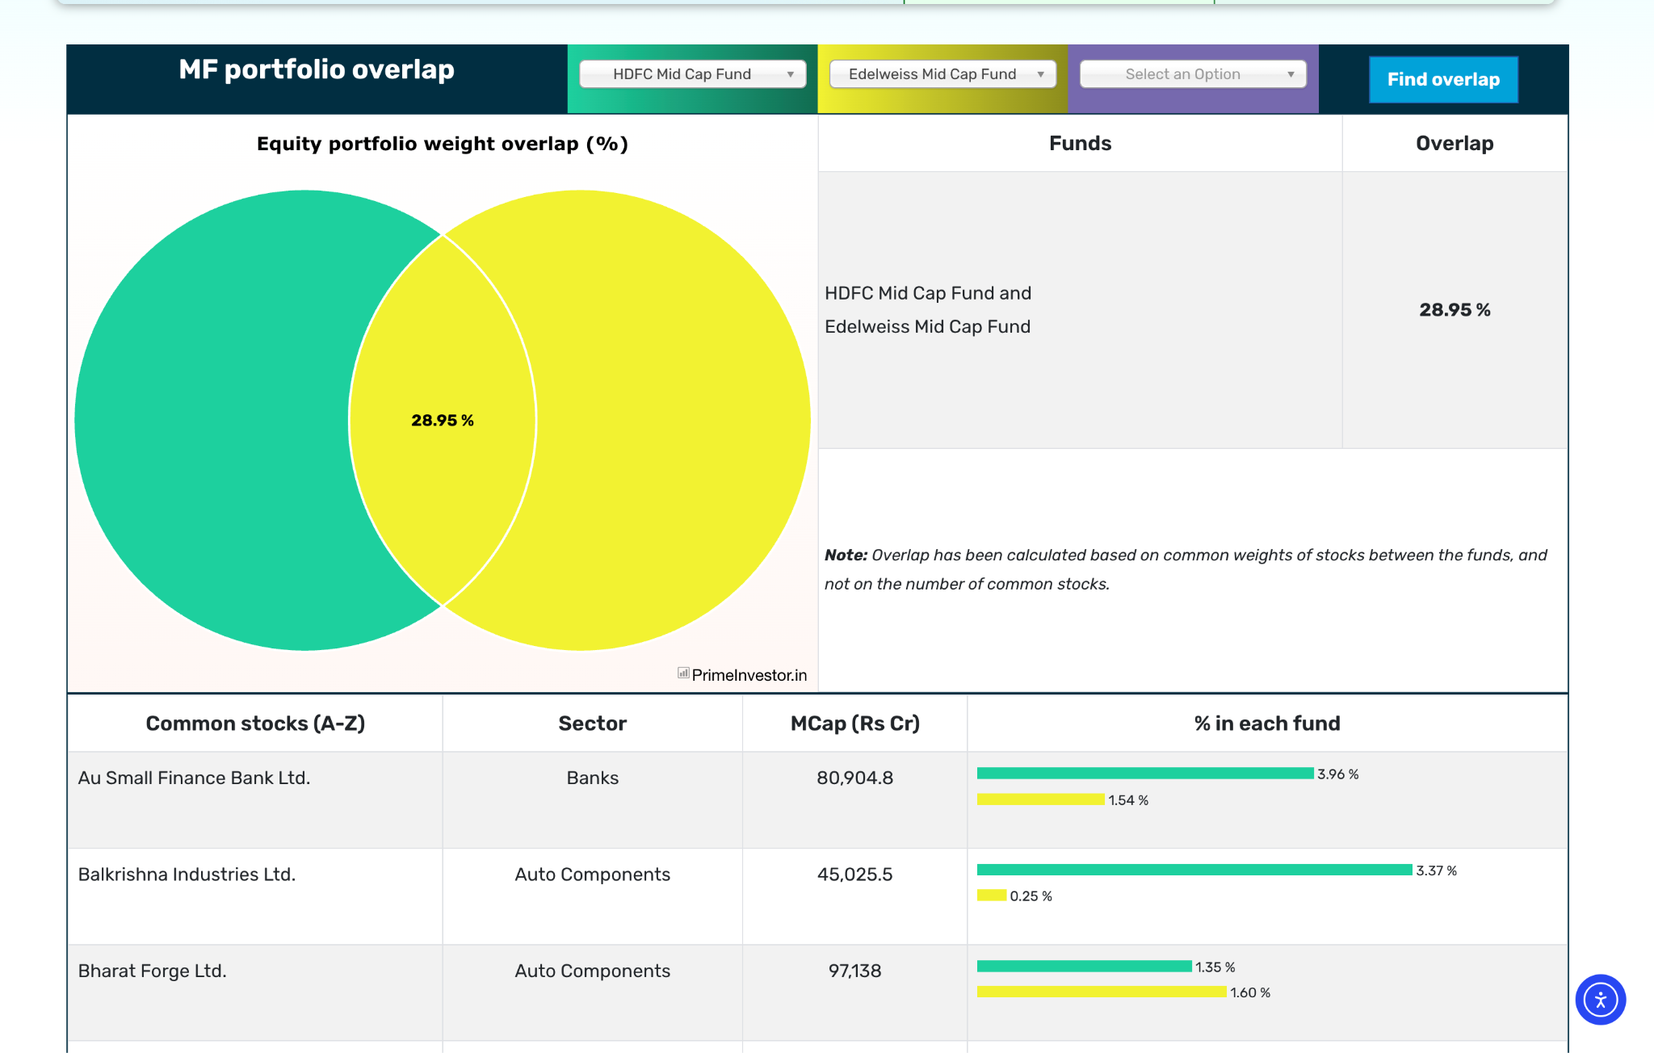
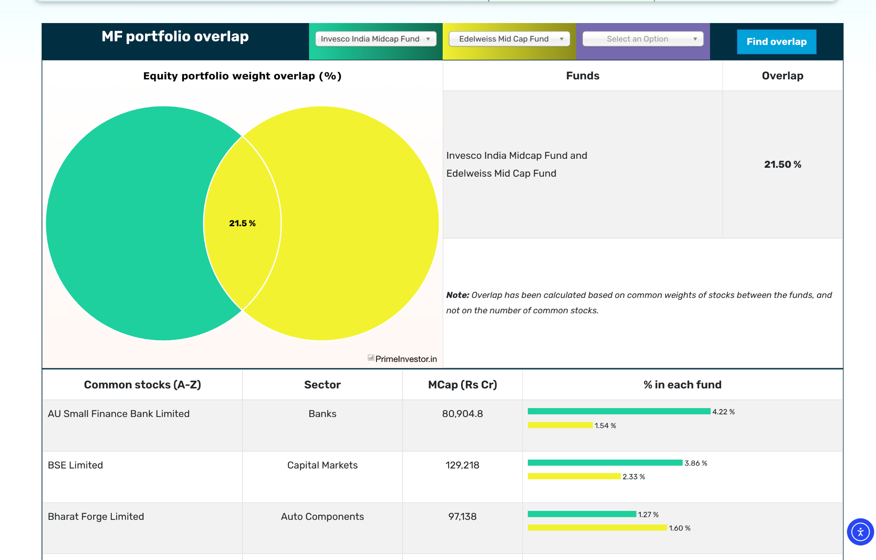
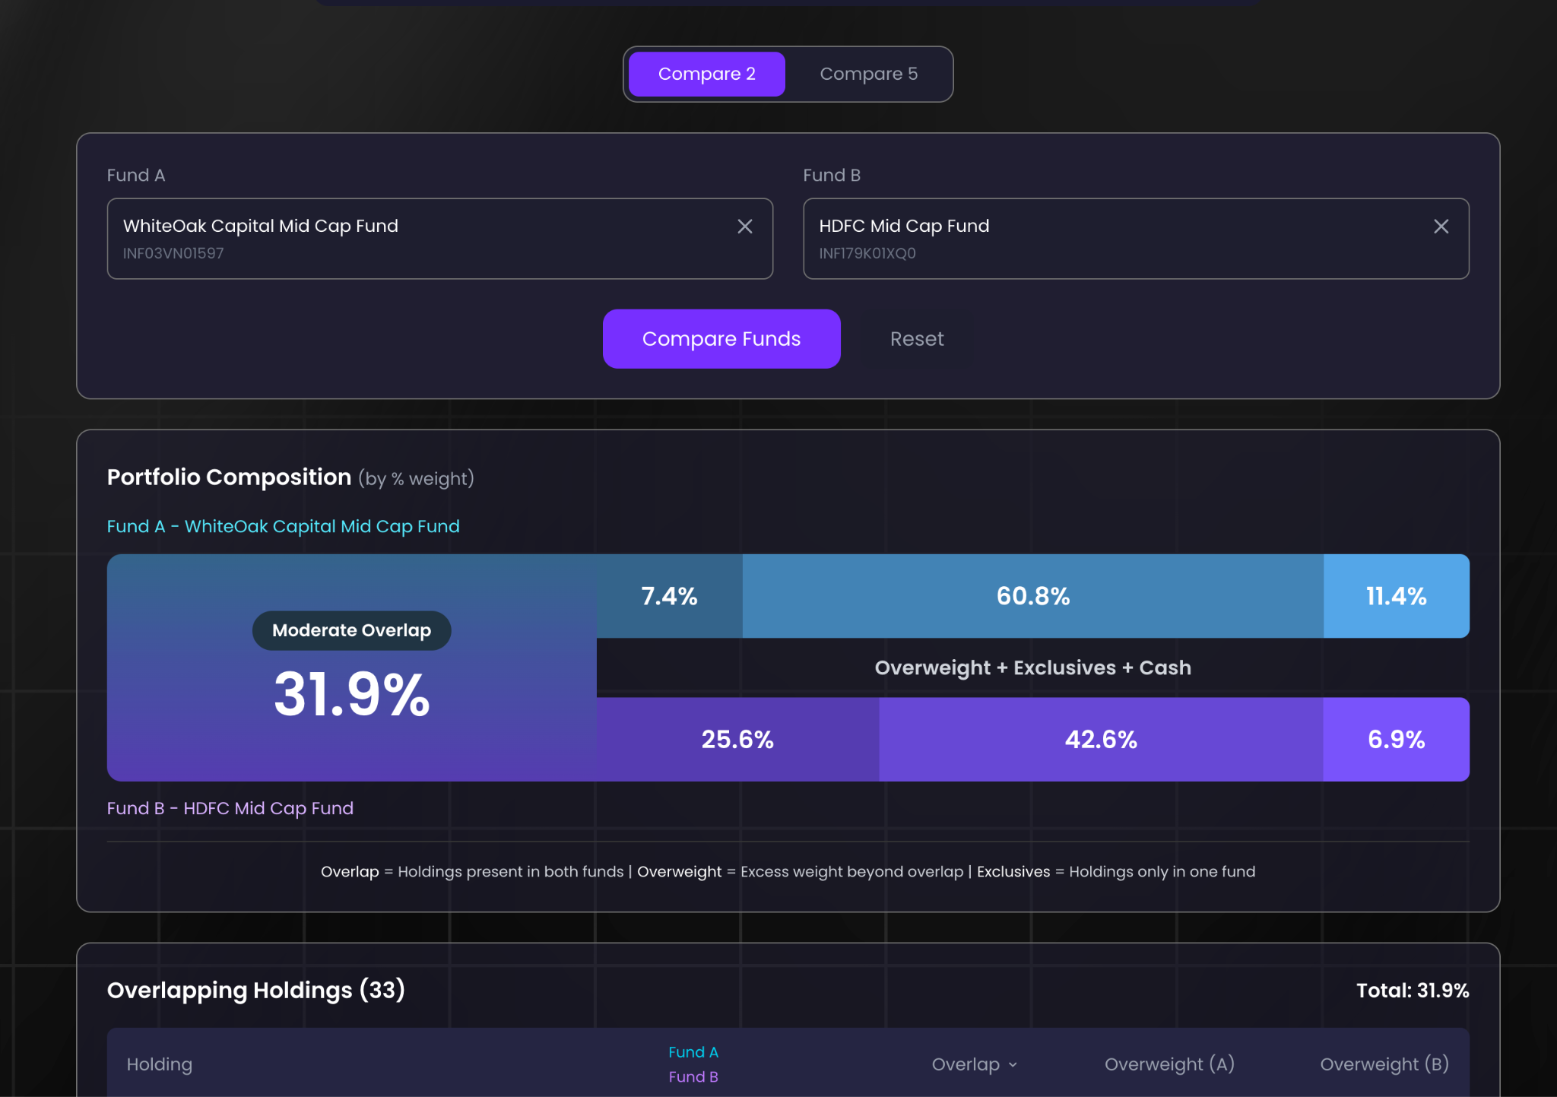
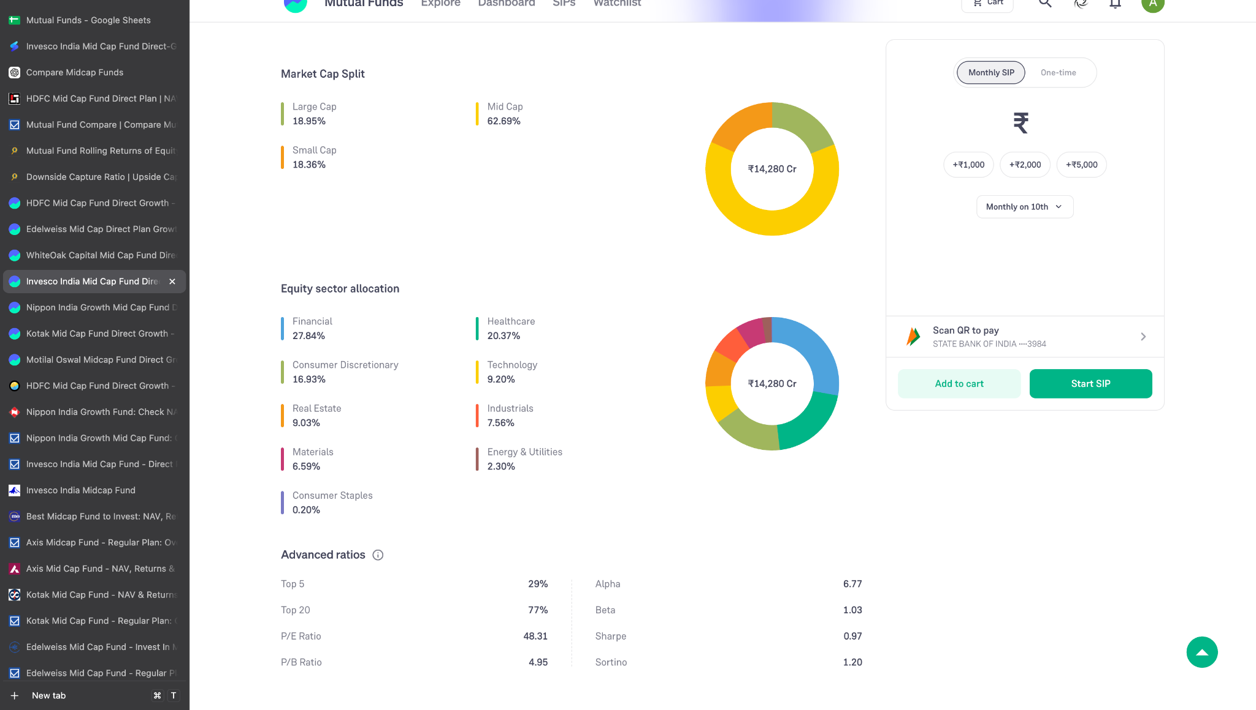
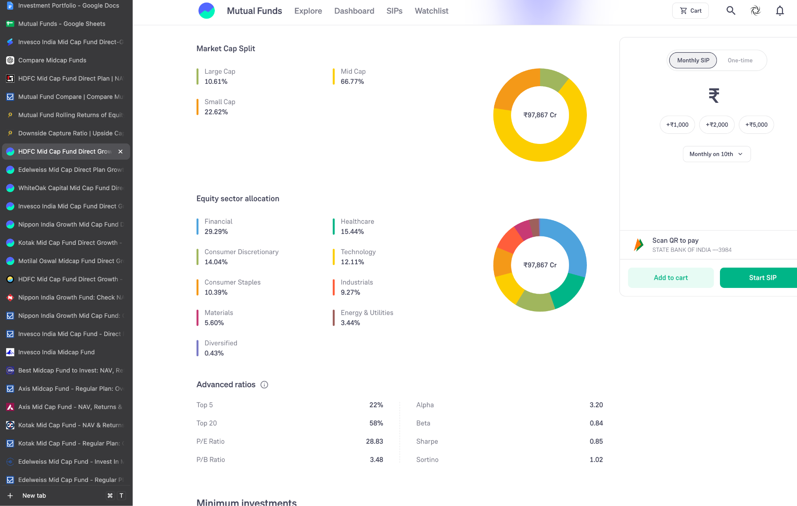
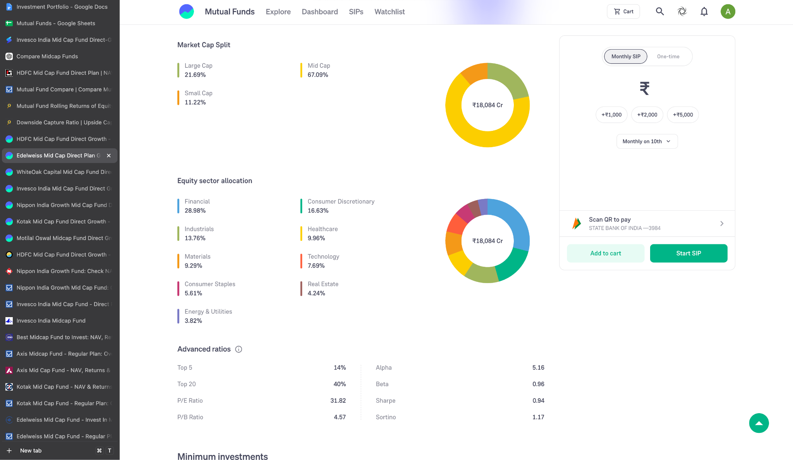
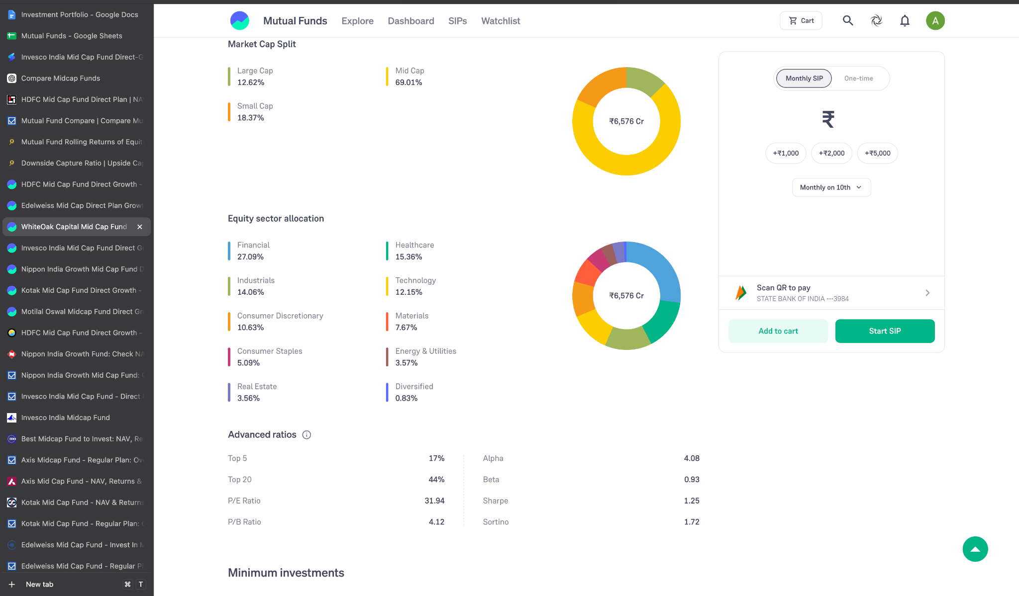

invesco hdfc seems opposite one up one below, edeil centre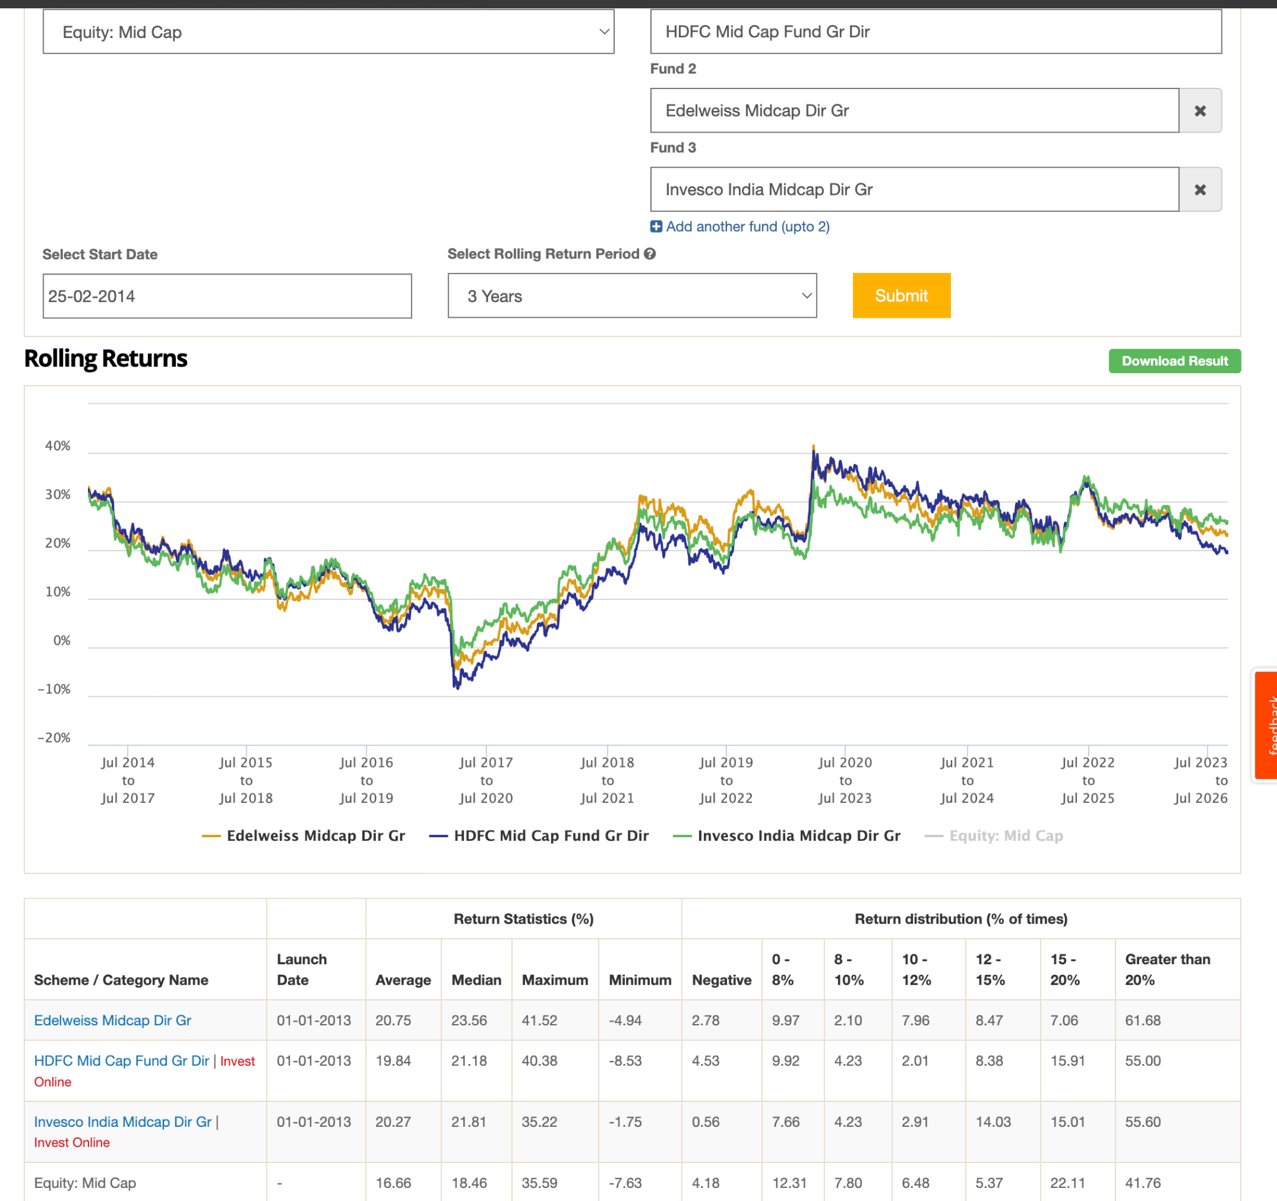
Mostly: invesco, hdfc, edelweiss, white oak

Small Cap
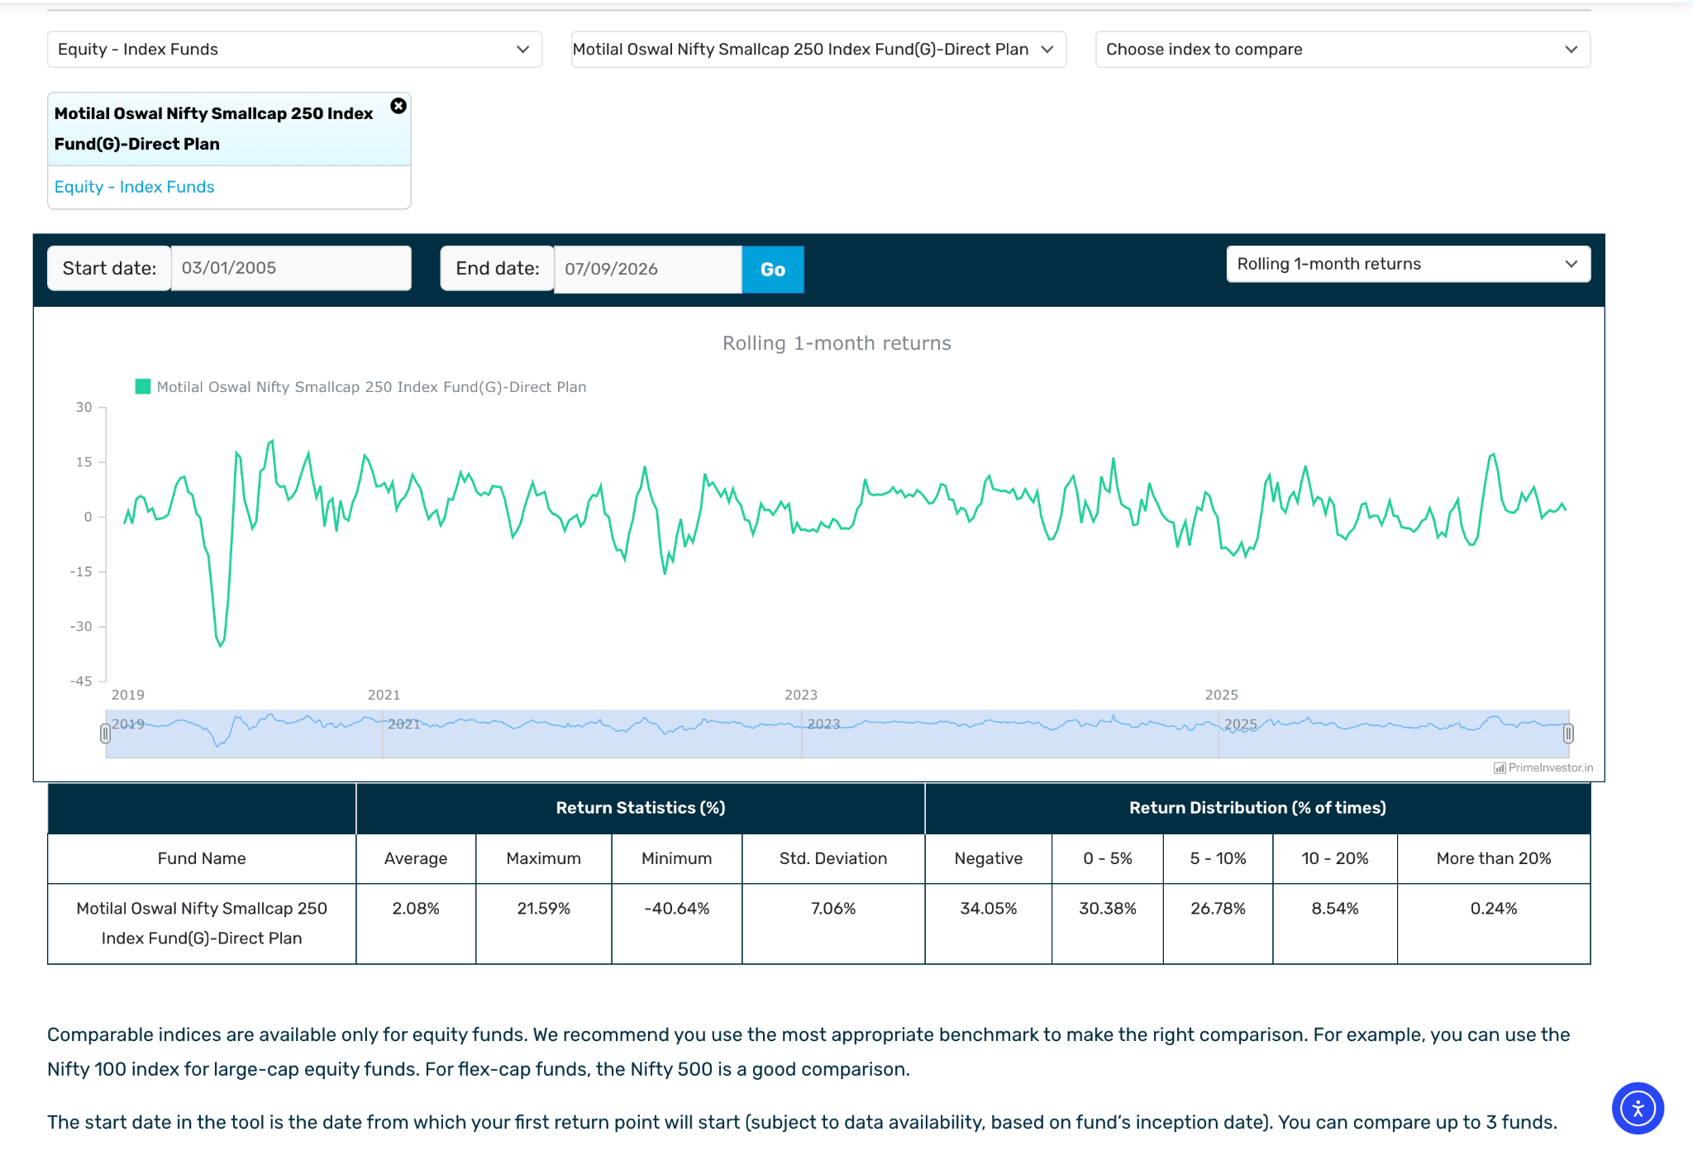

-41.73 -> corona small cap 150 tri

Category 1 ( worst or very new )

- ABSL Small Cap Dir-G :
  - This start 2014,
  - -39.72 in corona
  - seems after corona go bad performance: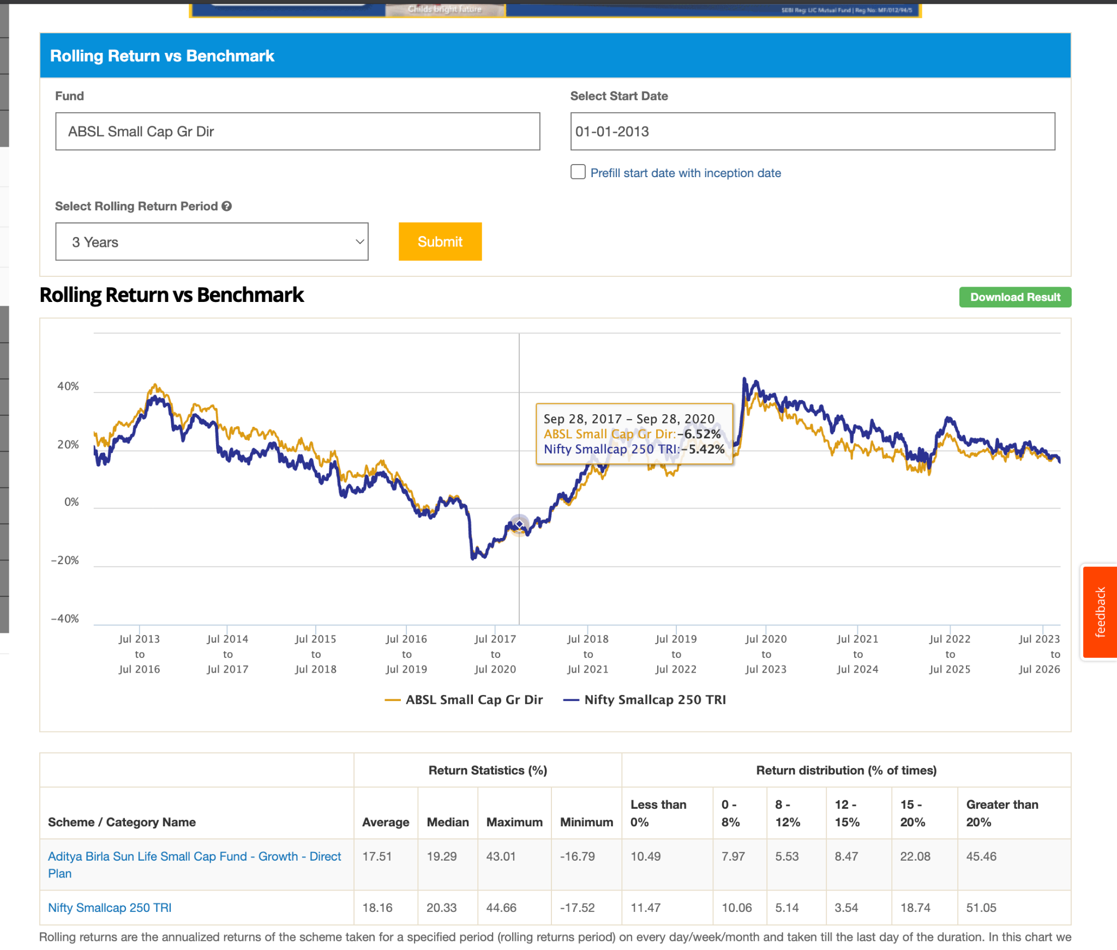
  - 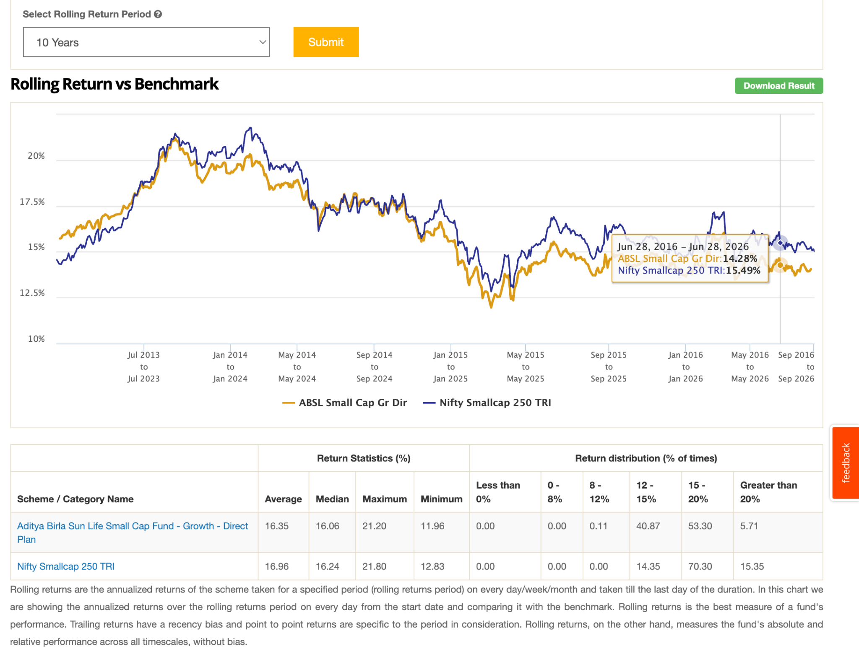
  - basically not consistent as we can see have like 5-7% as well in 5y, so its not like lost money but have high differnence to index.
- Abakkus Small Cap Dir-G: ignore started 3 months ago. but got 2k interestingly people beating seems those who have good money. seem good observe this in future ( also has 2k crore also : ) , 1.27 er
- Bajaj Finserv Small Cap Dir-G : started 1 year ago, in one year looks good ( 2,364 cr ), ( only 0.95 expense ratio ) , observe this.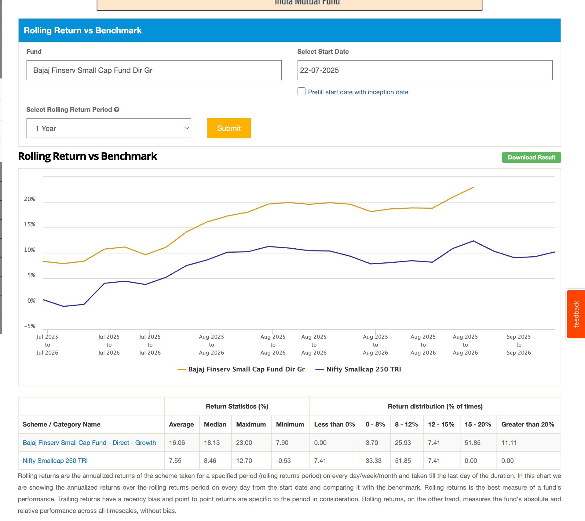
- Baroda BNP Paribas Small Cap Dir-G: ~3y ago, seem not like bad touching , 1.3k . 1.21 er. can ignore this 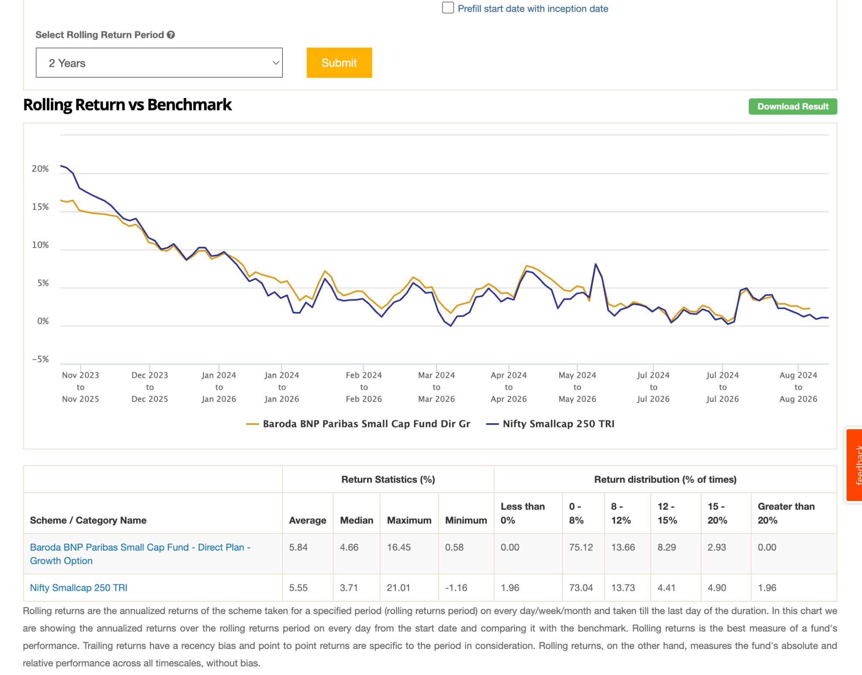
- Groww Small Cap Dir-G: very new launch in feb: ( 570 crore ) , 1.01 er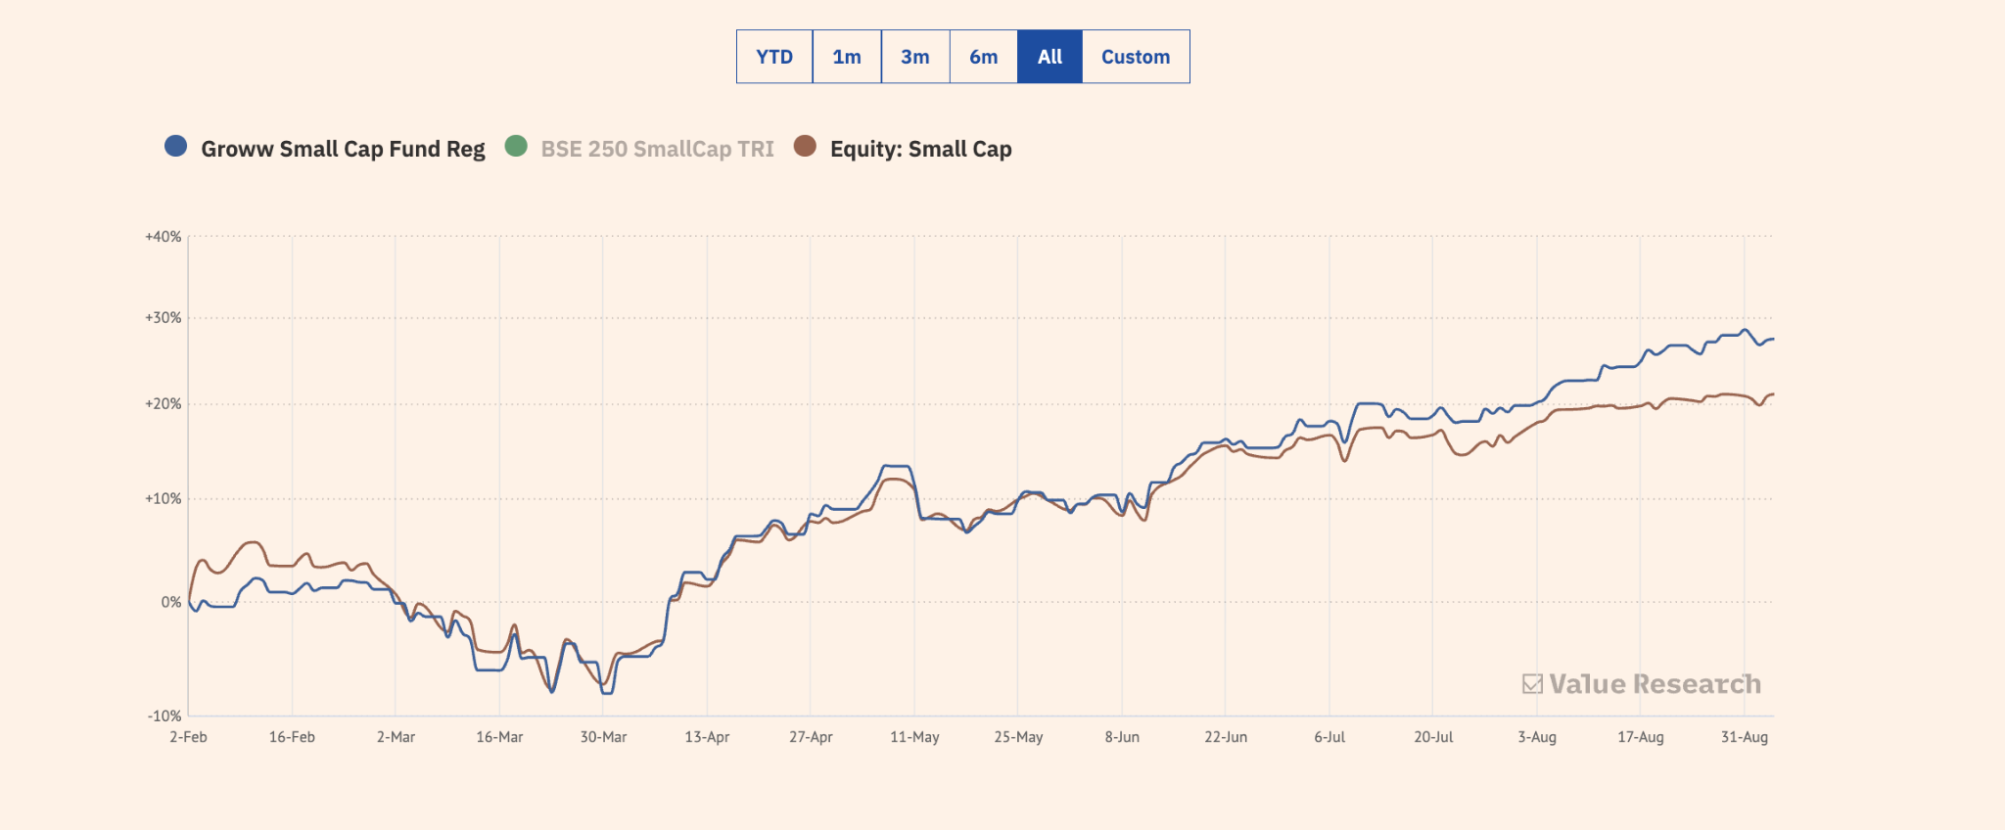
- Helios Small Cap Dir-G : 10 months, 1.5k , 0.97
- 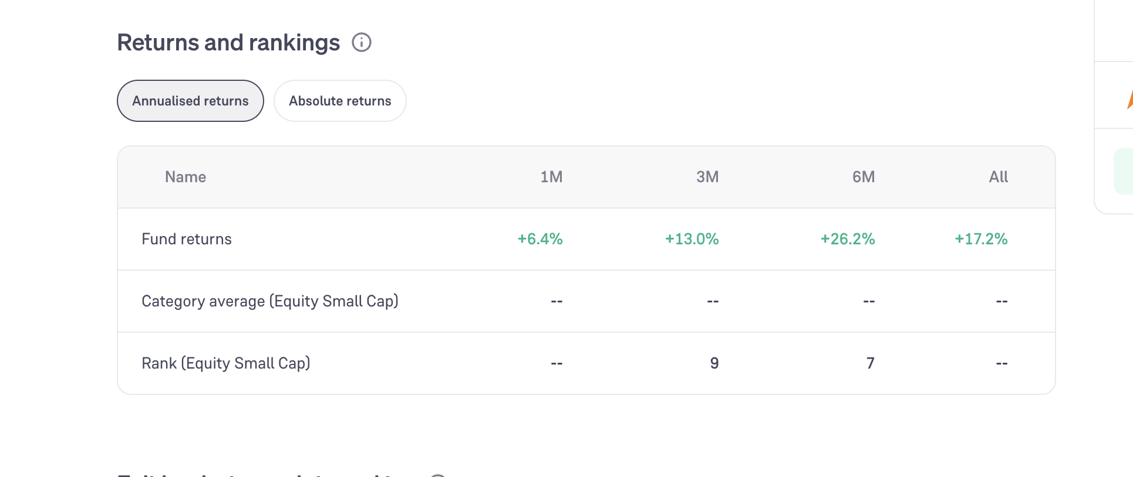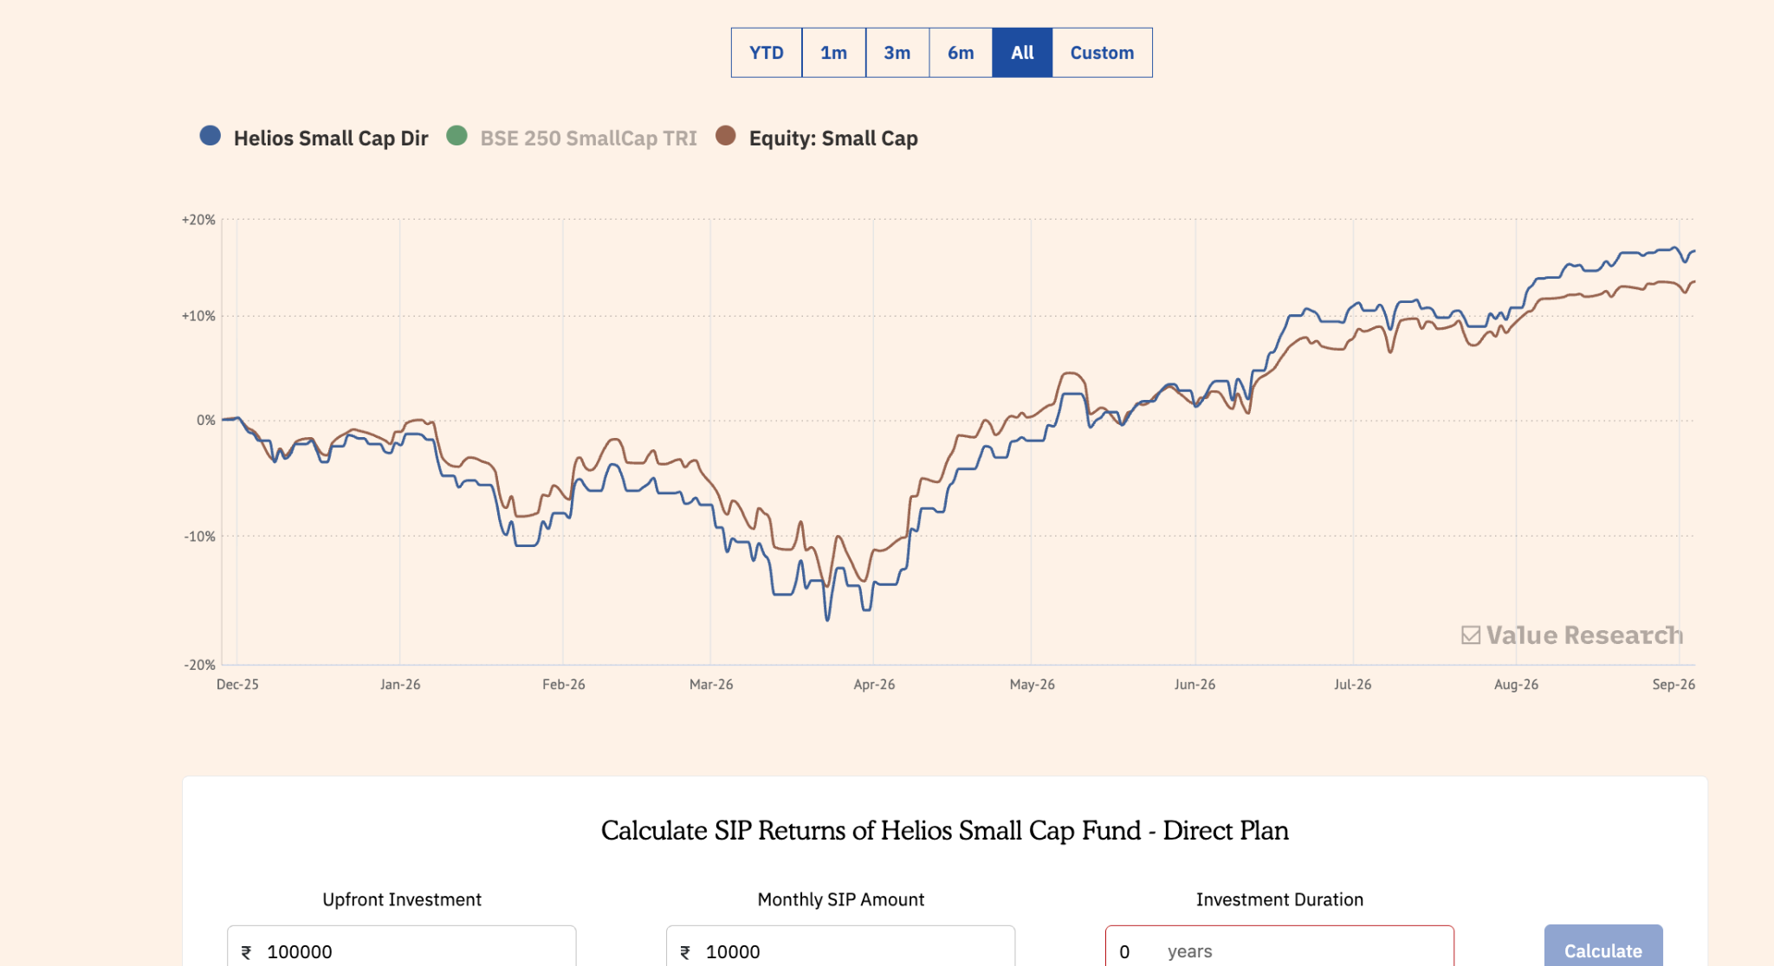
- JM Small Cap Dir-G: 2y ago, 868, 0.97
- Mirae Asset Small Cap Dir-G: 1-1.5y, 5.2k, 0.65, observe
- Motilal Oswal Small Cap Dir-G: 2.5y, look cool, 7.6k , 0.86 looks very good return in 2 year. consider this definitely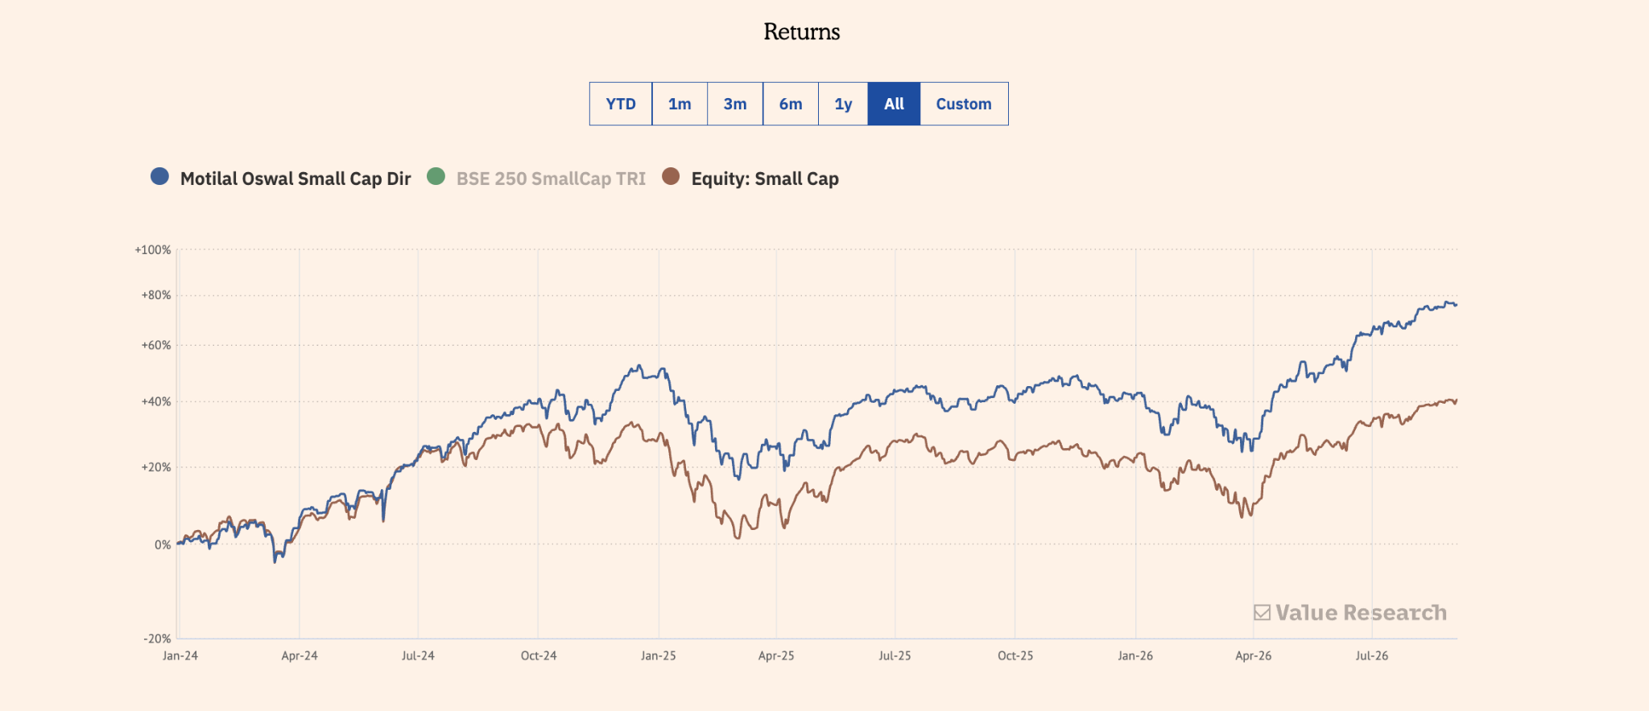
- PGIM India Small Cap Dir-G : 5y old, 1.7k, 0.93, worst, not negative but very less, these are the funds those fear us. may be in fture beat but right now have high diff.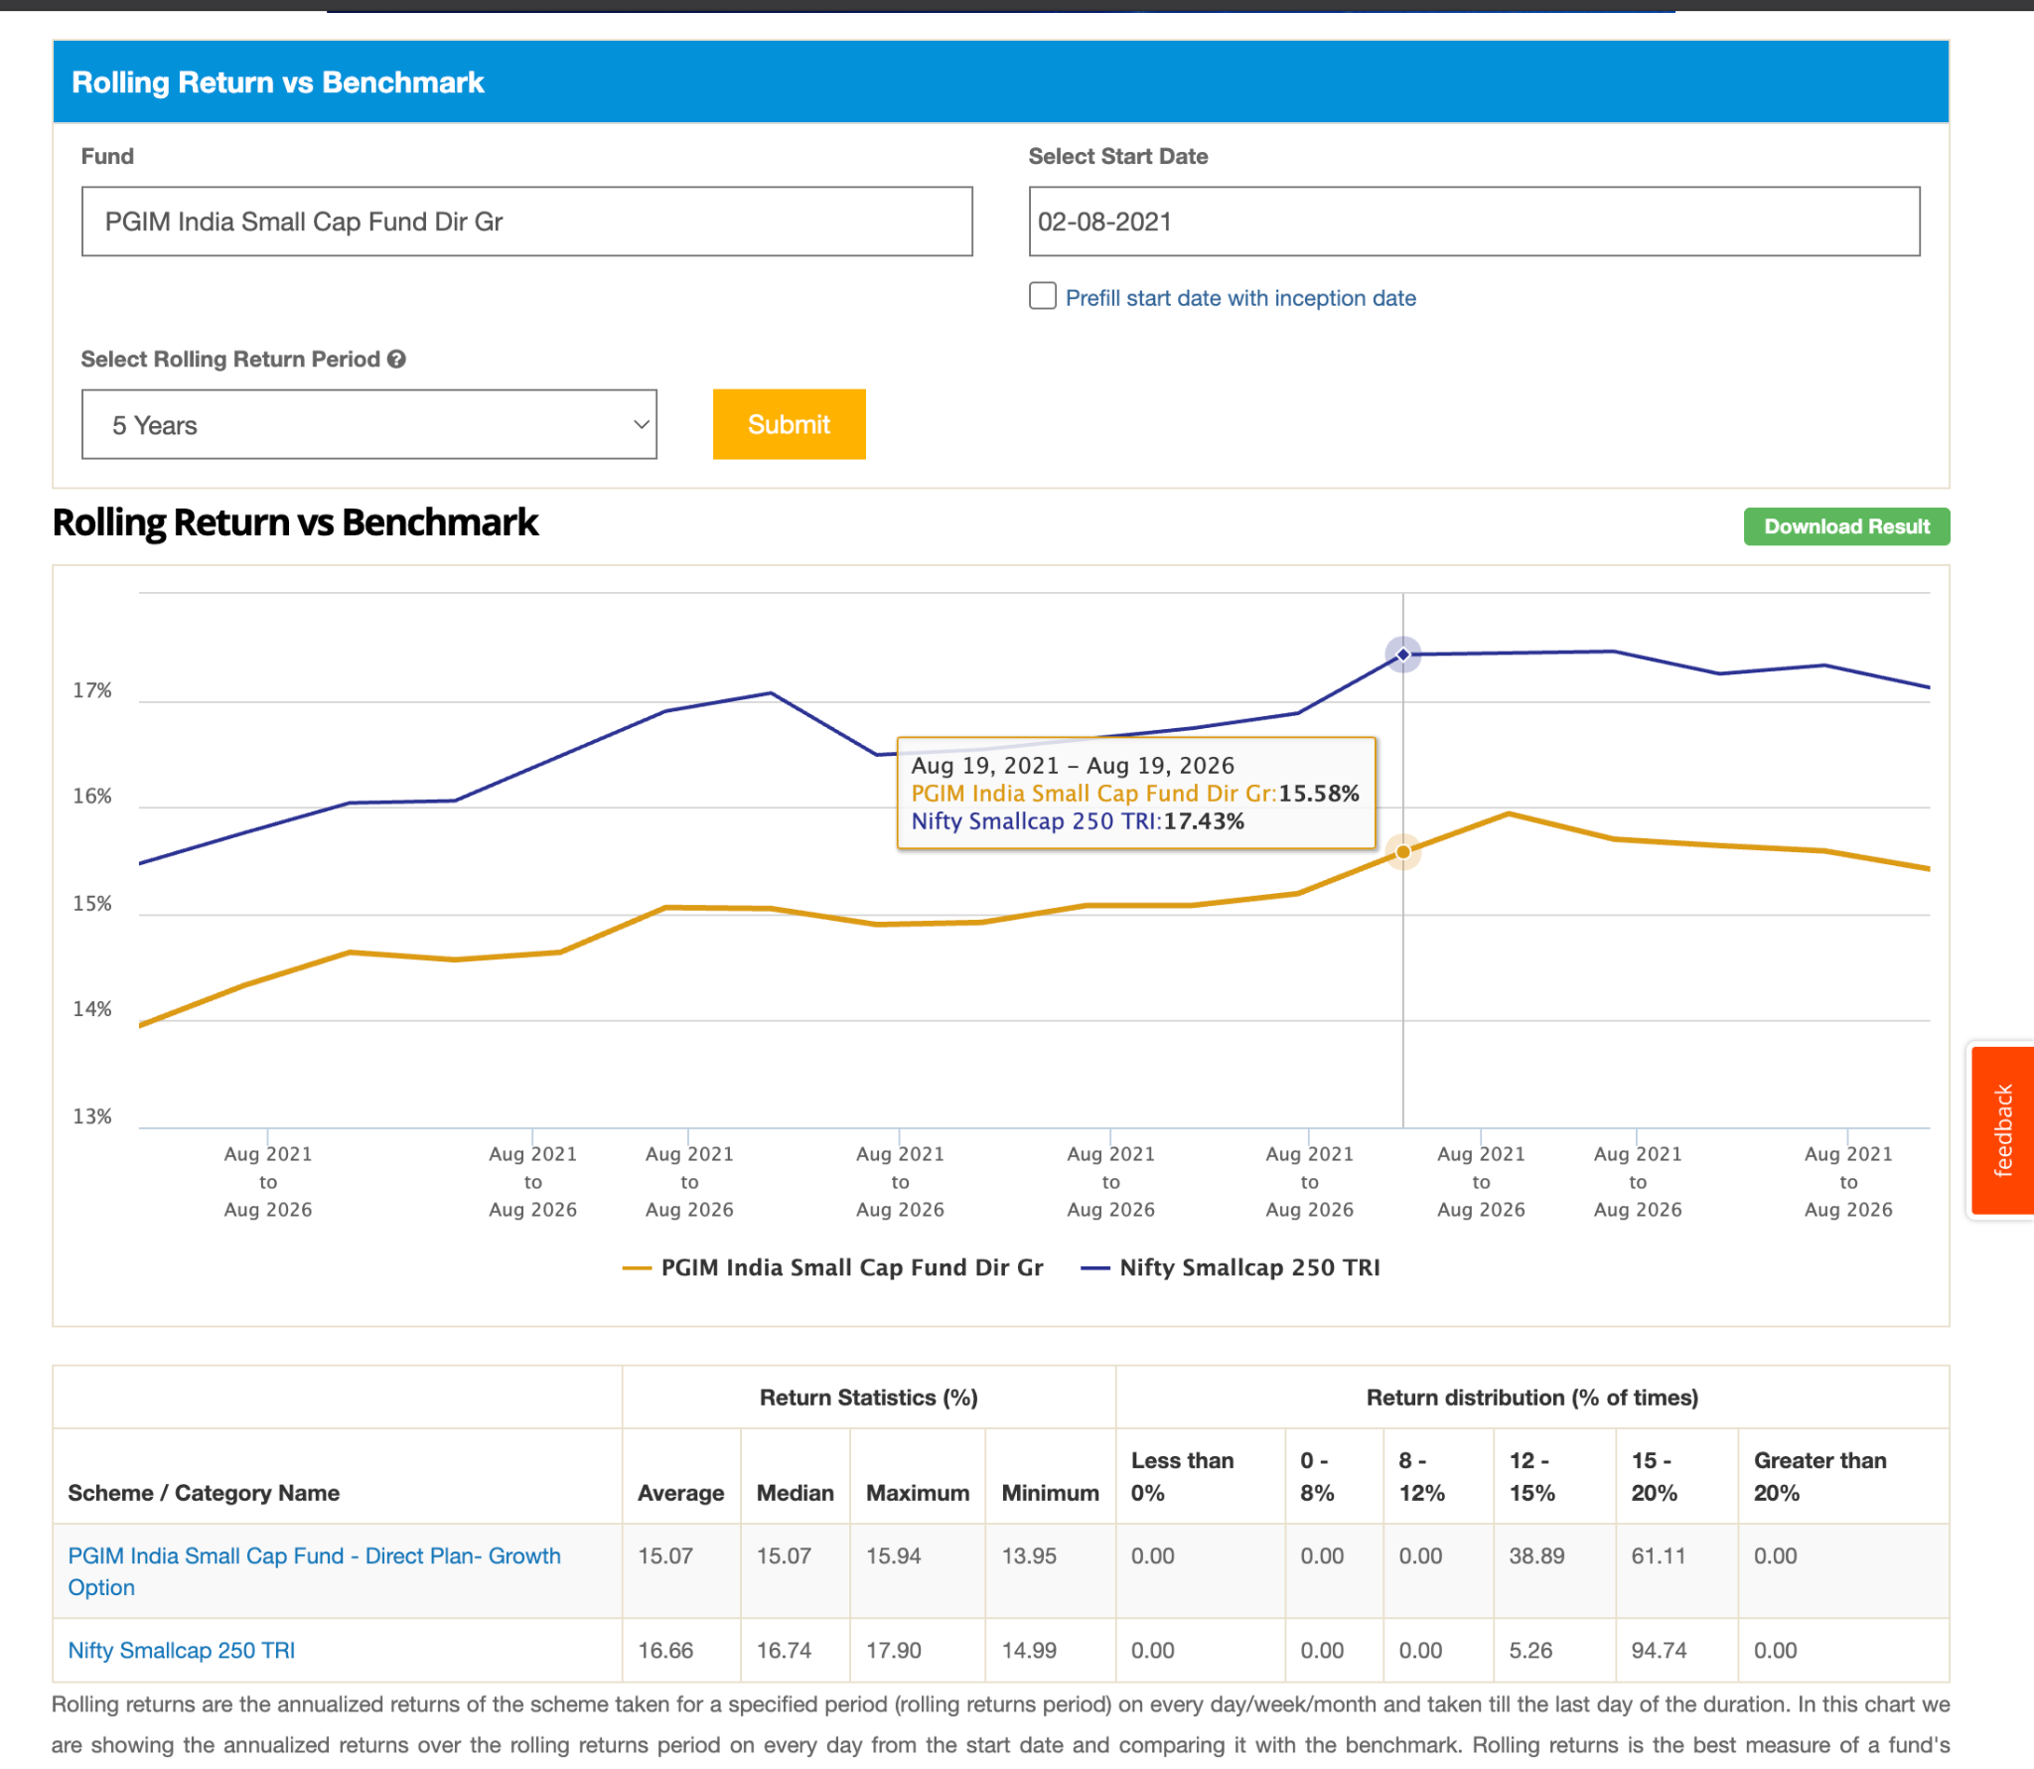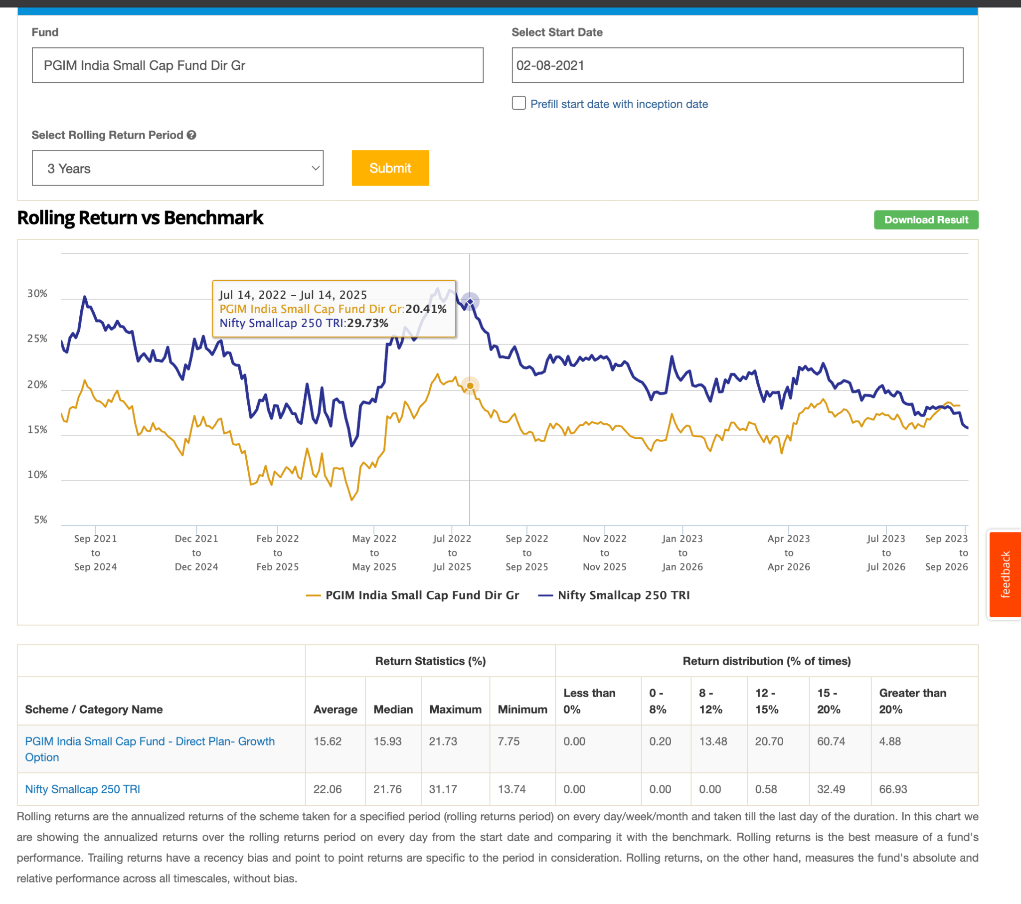
- Quantum Small Cap Dir-G: 2-3y, 254, 0.83, seems not one interested, 1y 2y rolling is above idnex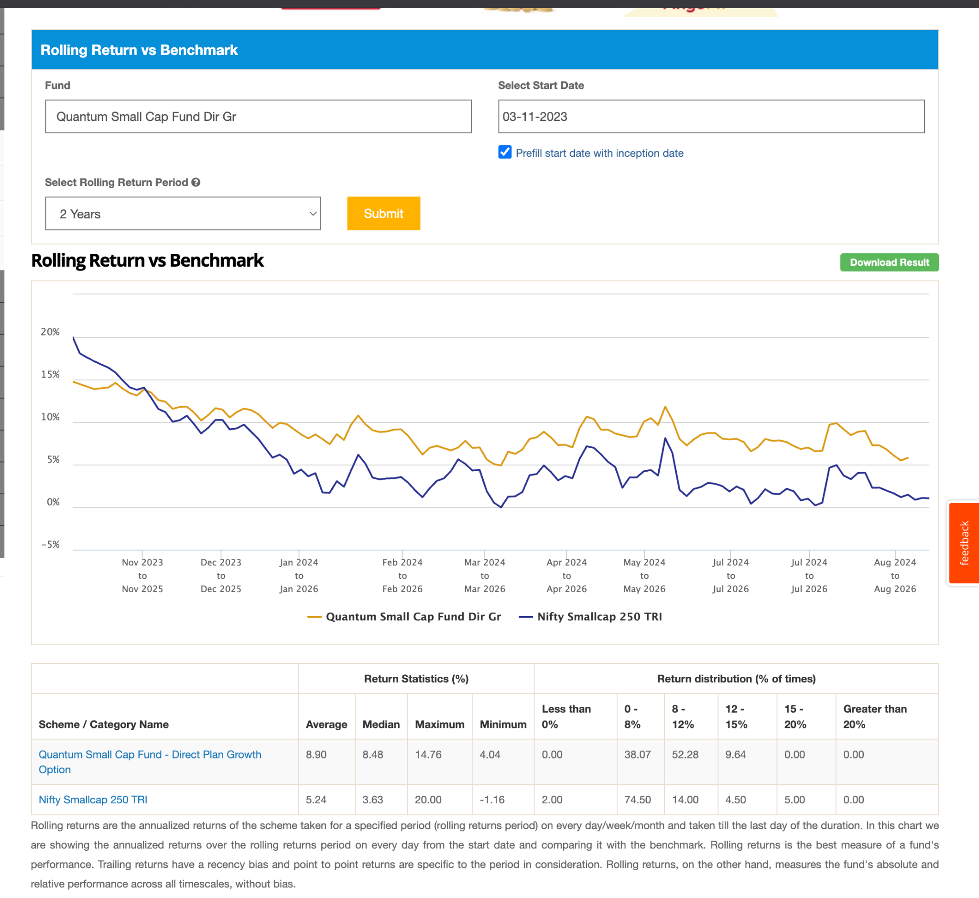
- Samco Small Cap Dir-G: jan 26, 170, 1.97, ignore for now: 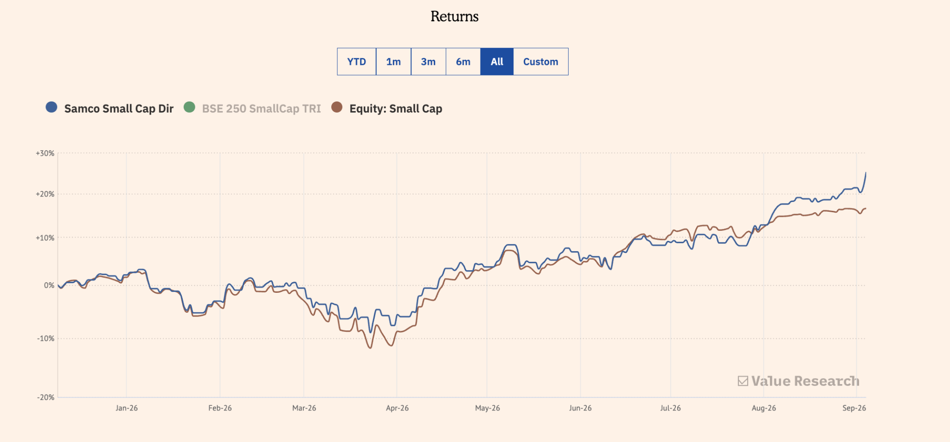
- TRUST MF Small Cap Dir-G: 2.8k , ~2yold, 1.54. 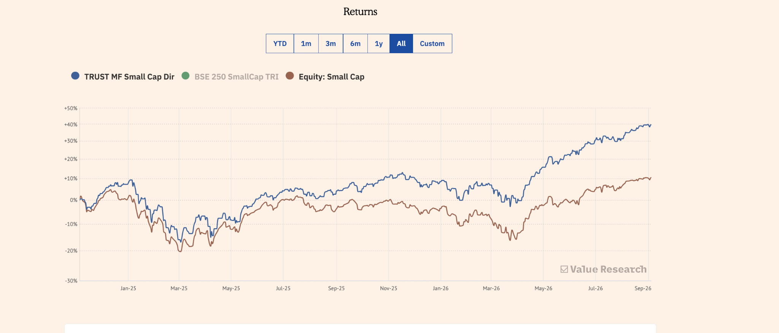 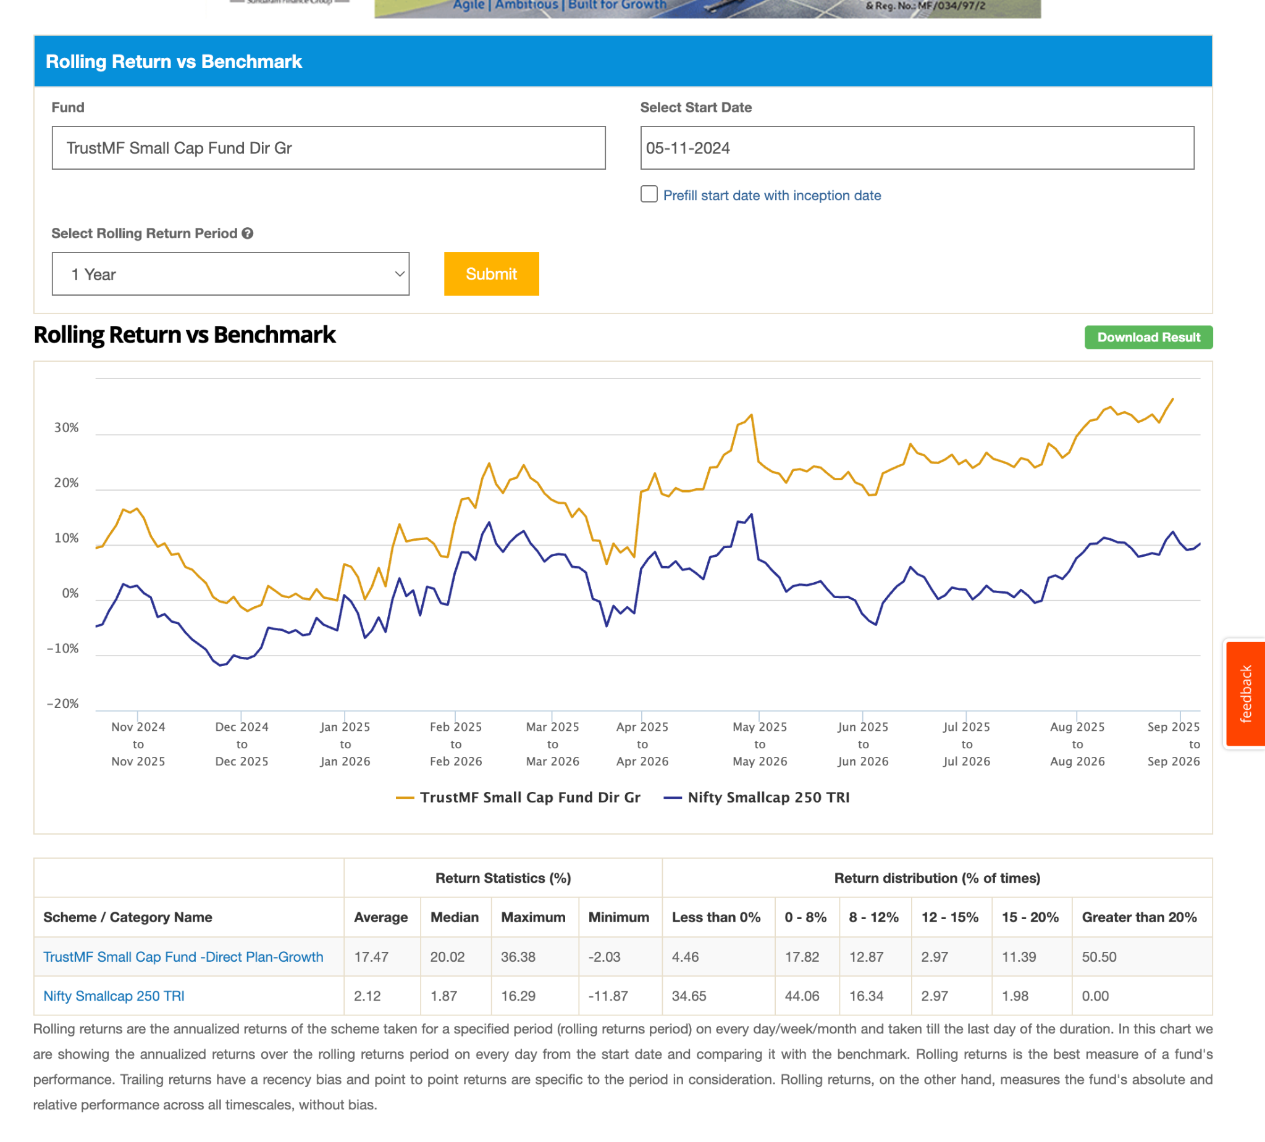
- The Wealth Company Small Cap Dir-G: 3 month ago ignore this: 105, 2.05

Looks except couple of fund other are very new not much to comment but as of now performing well beating index. also those who didn't beat check reason, its not like lost money but inconsistent inbeating.

Category 2

1. Axis Small Cap Dir-G: 12y, -33.77, 30k, 0.71, 10y beating handsomely, 7y also , in 5y seems after corno got hit, 3y is find can ignore after 2020 seems something wrong either after sebi rule or corno.1/2 year can be flucting seems they have consideration lnog term, that's why can see up and down in 1/e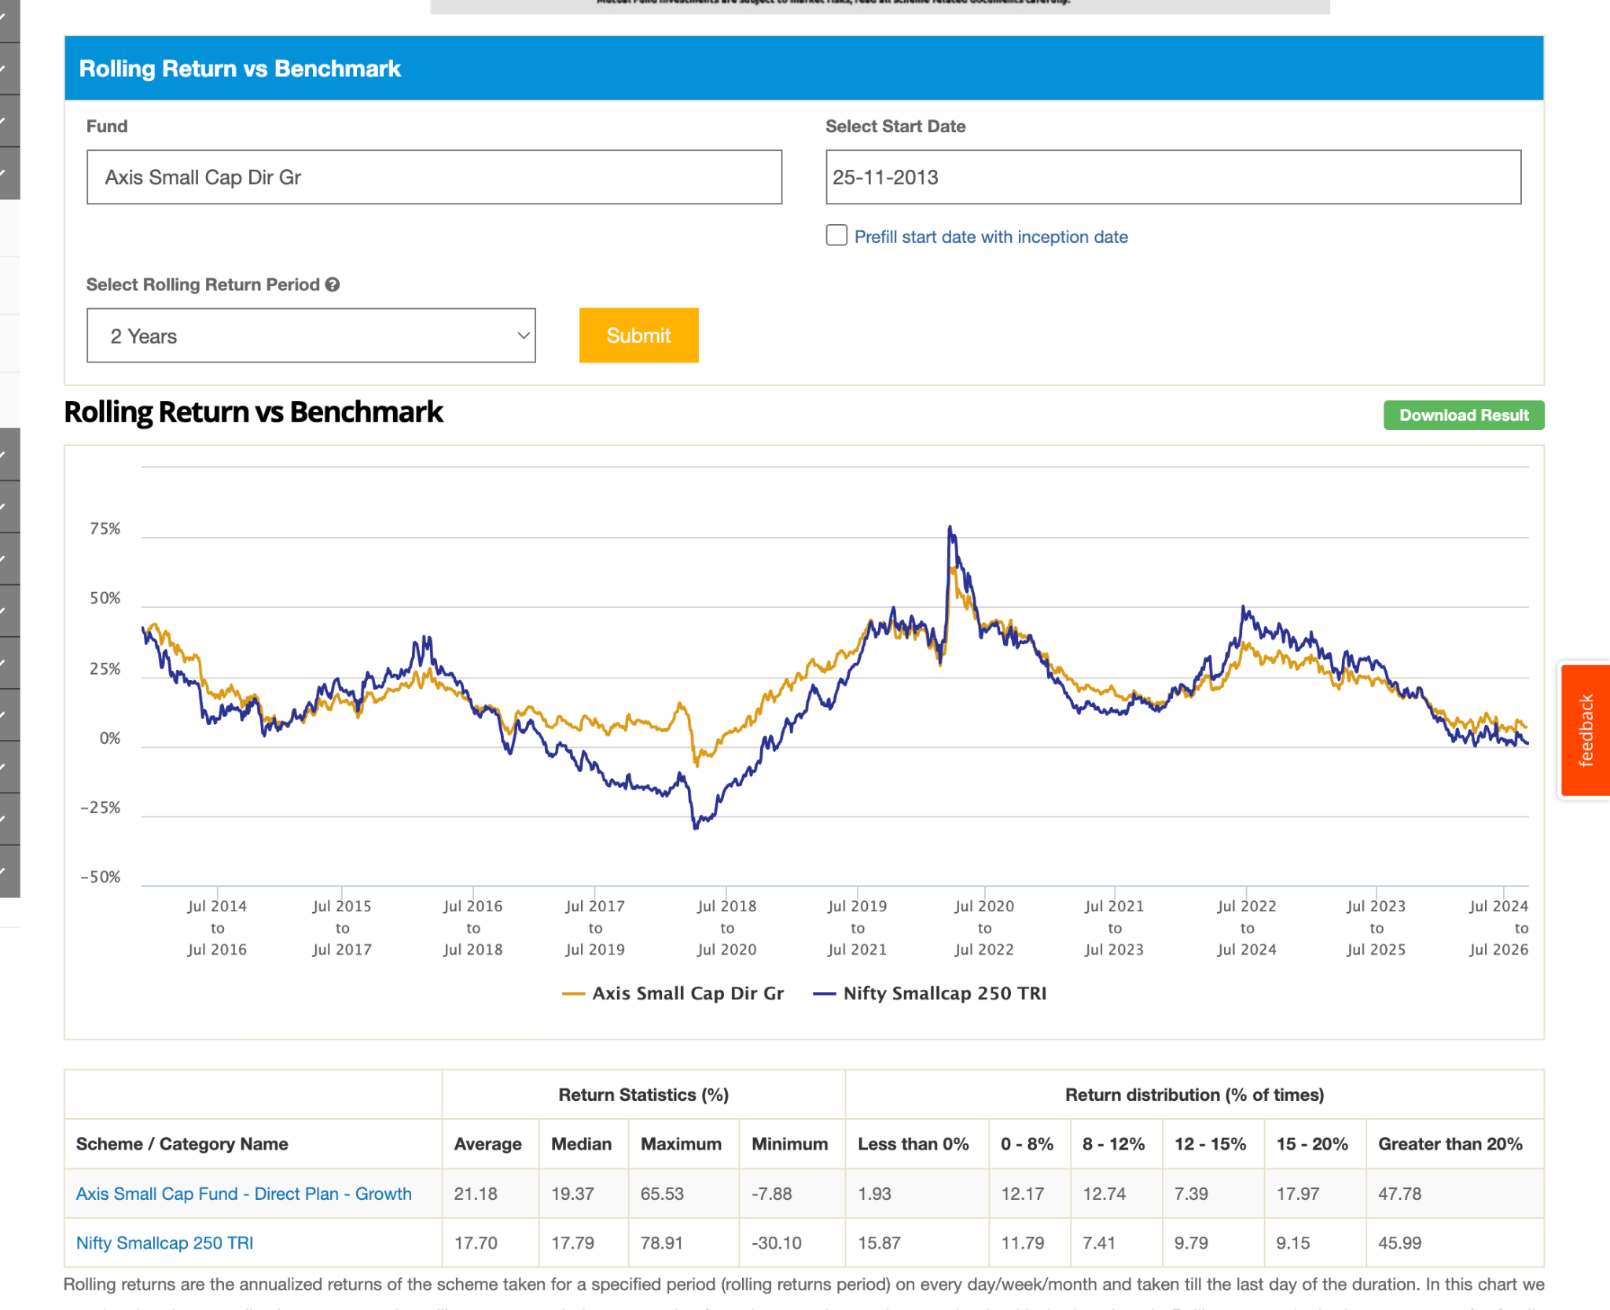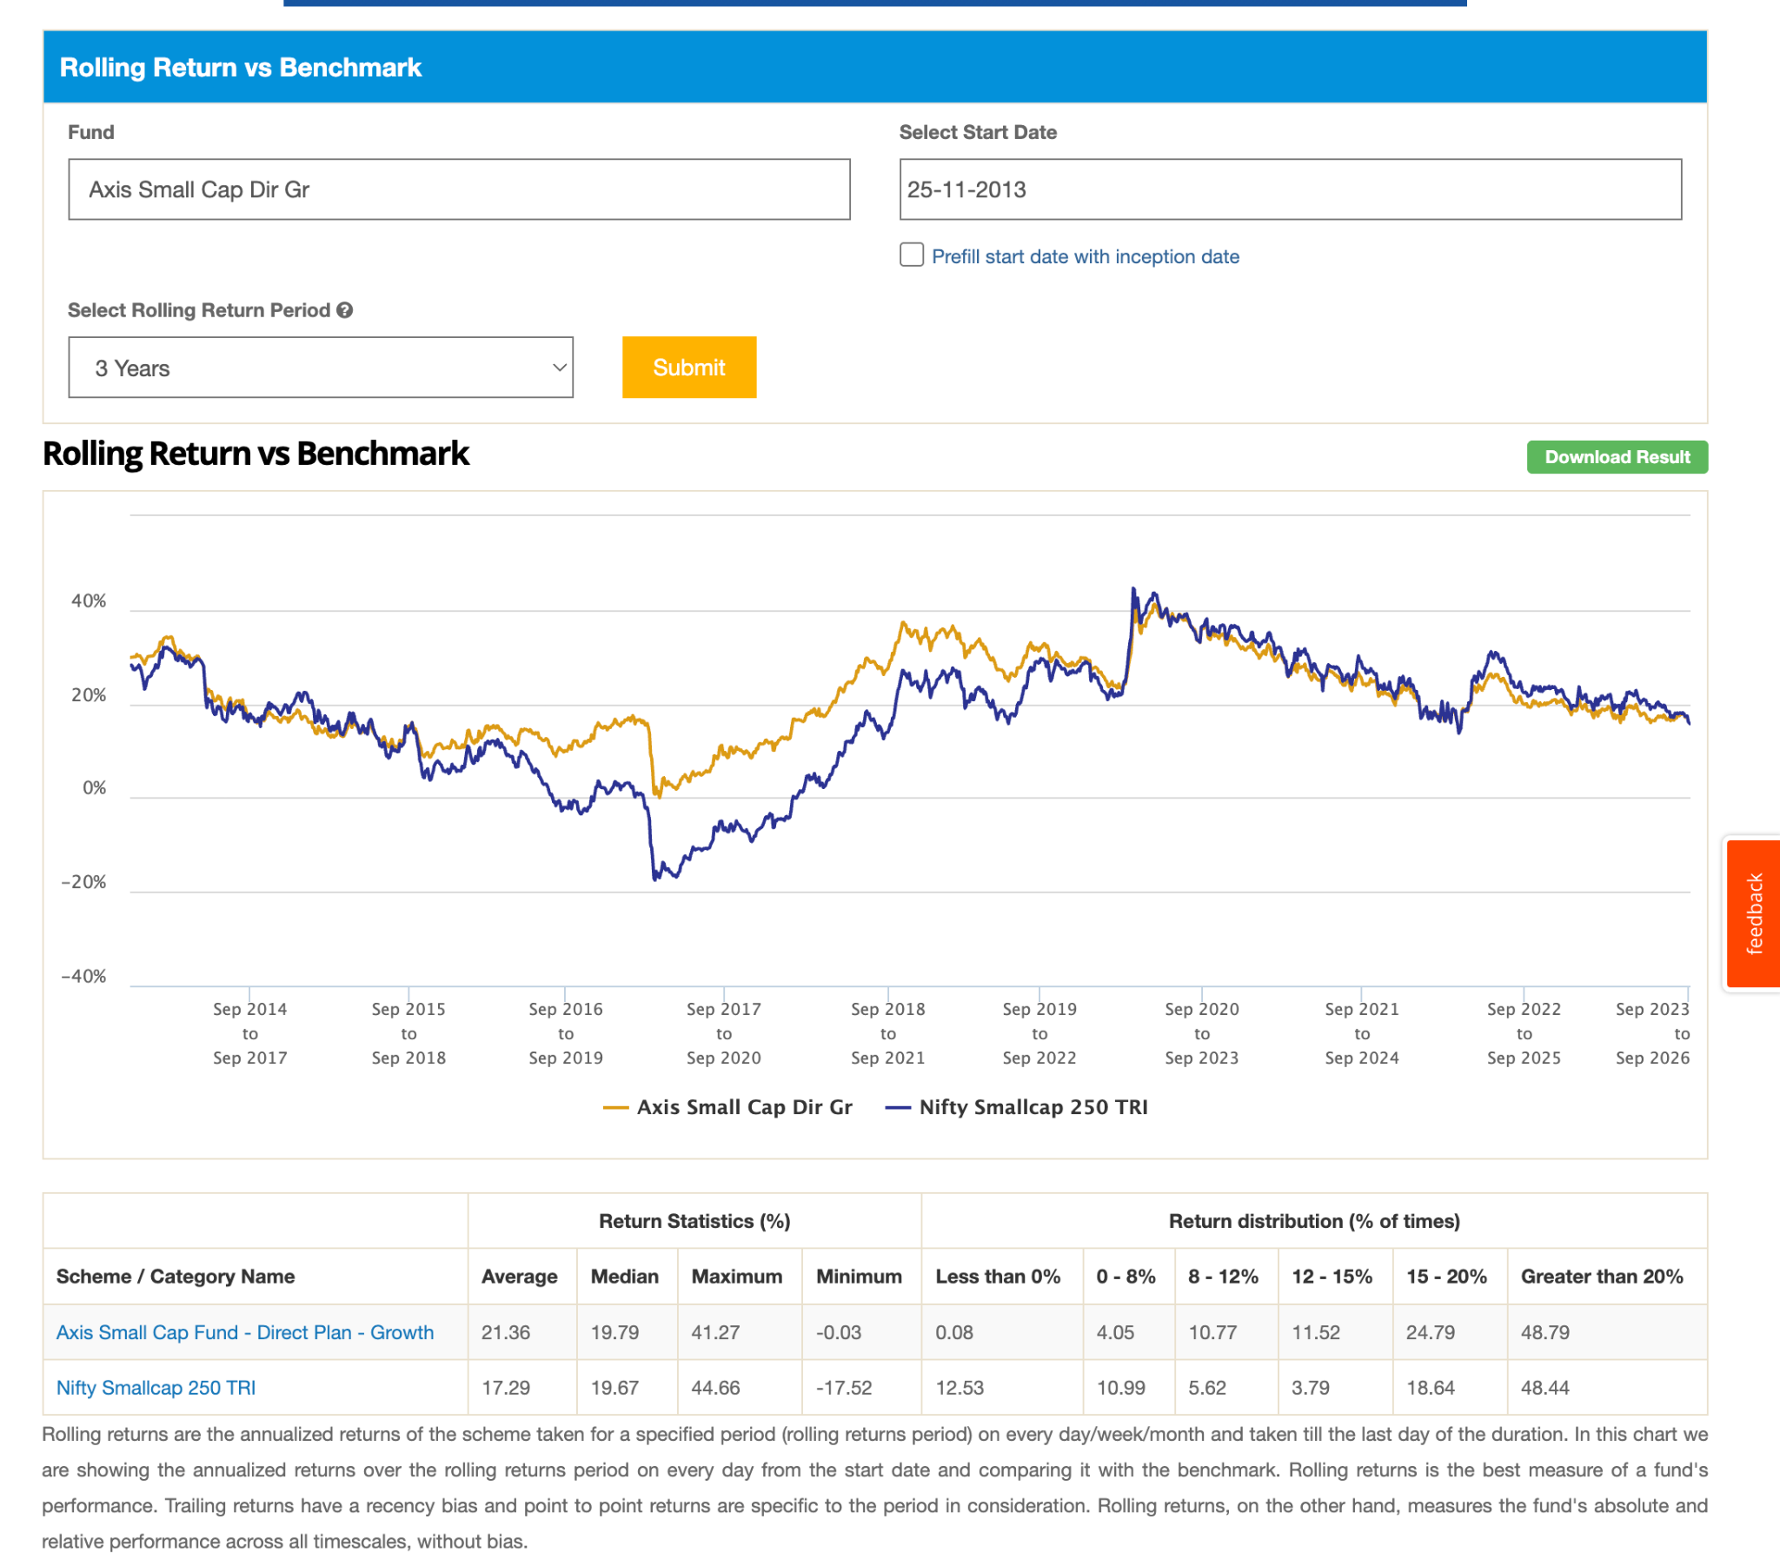 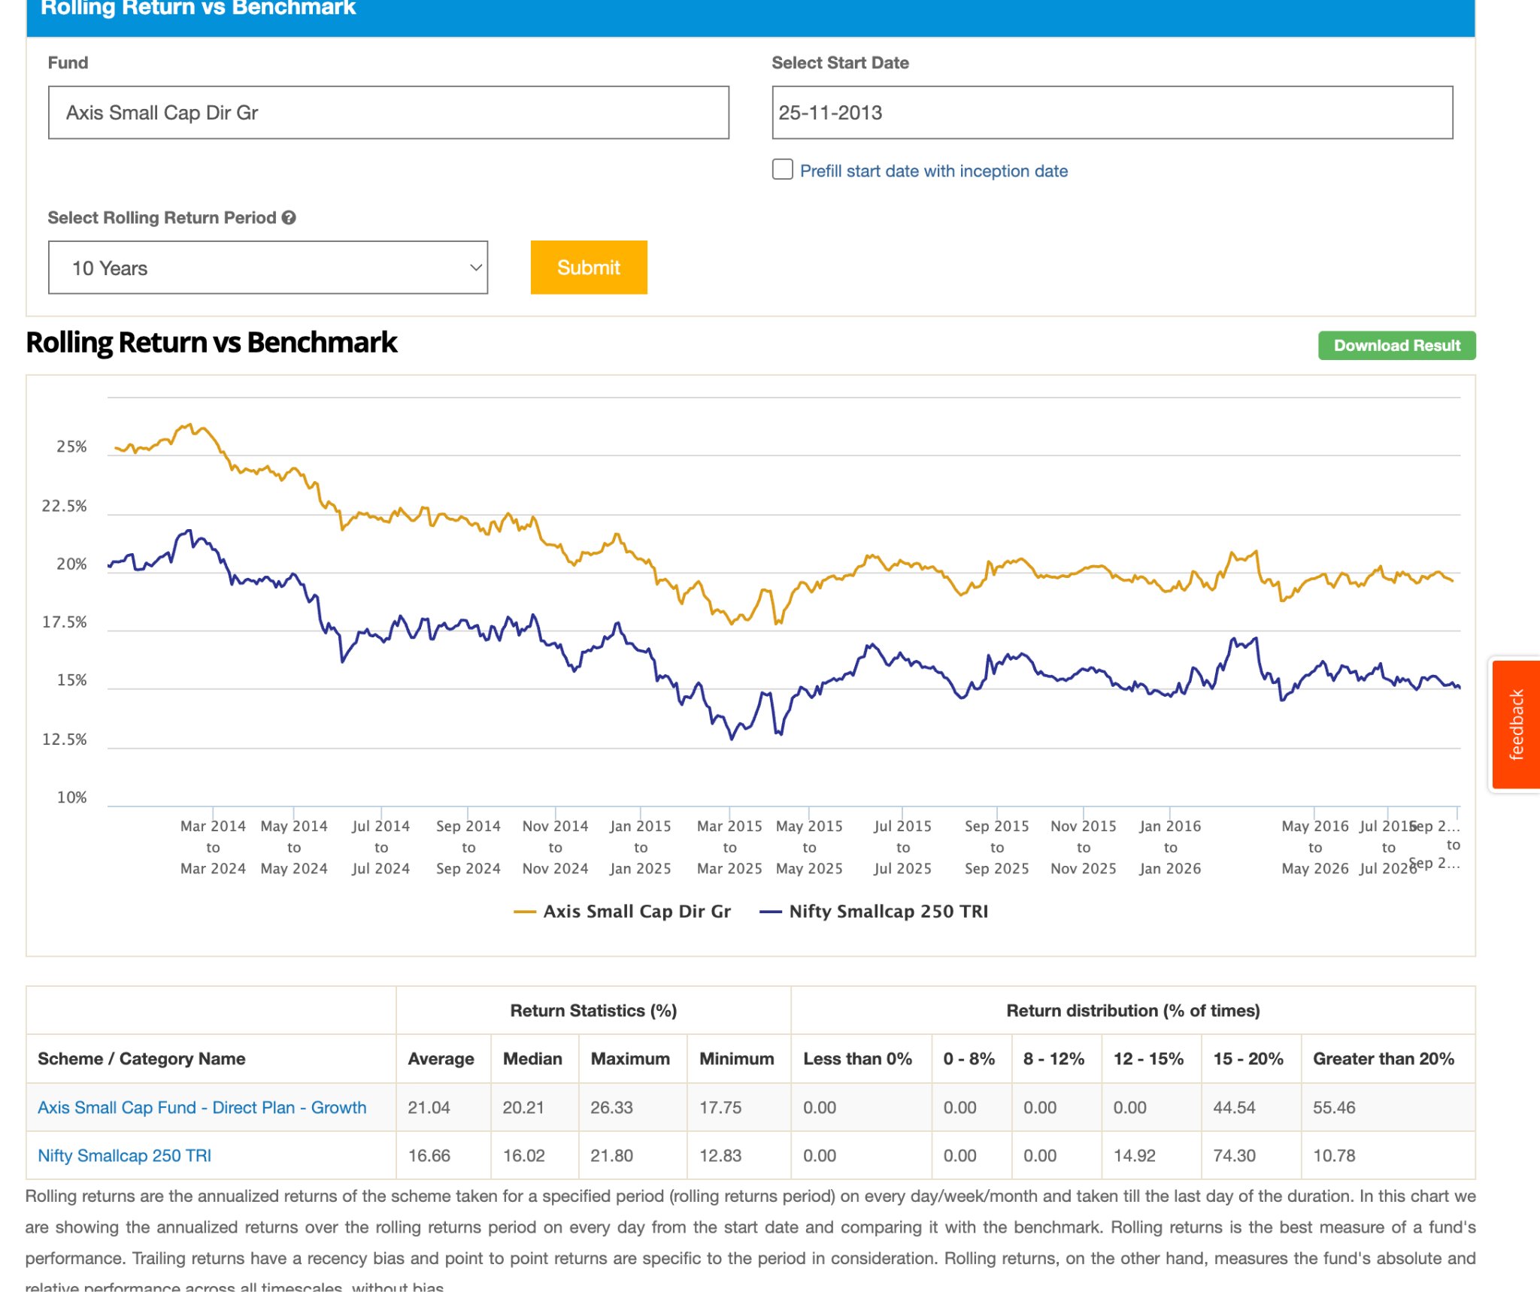
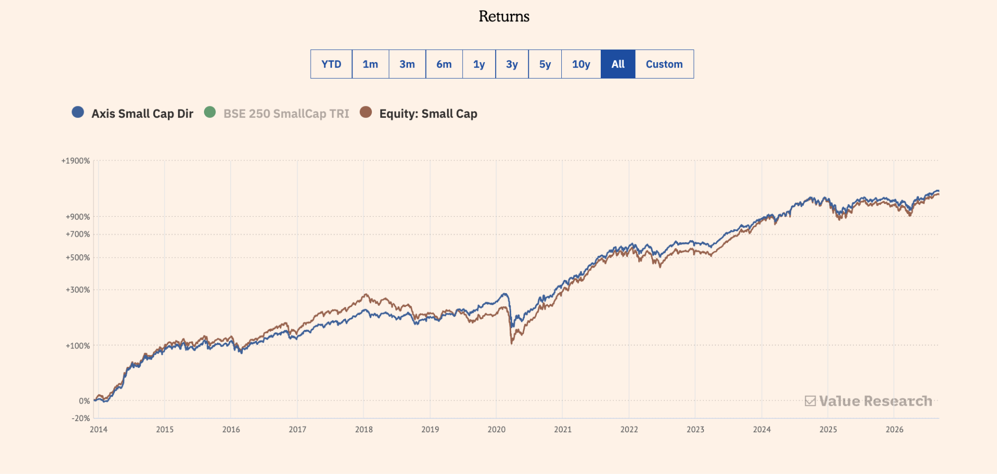
2. Bandhan Small Cap Dir-G: 31k, 0.58 , start at time of corno, no need to check rolling looks great already.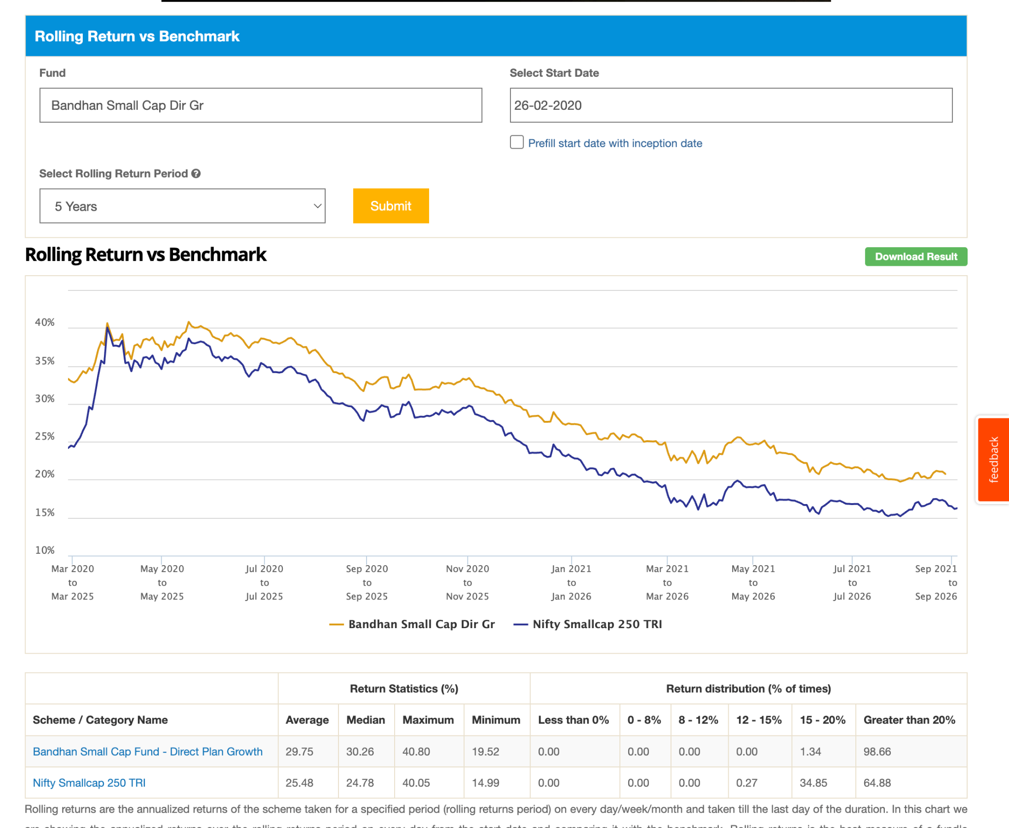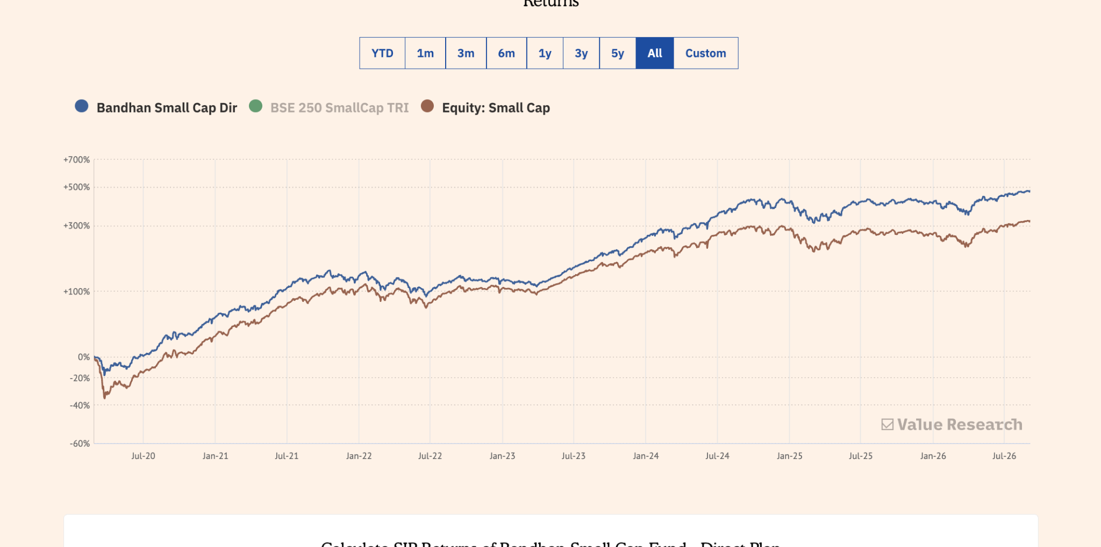

3. Canara Robeco Small Cap Dir-G: 2019 ( few months before corona ) , 14.2k 0.67. 7y handome, 5y beating after 2020 bit low, last 3 yer tough, observe seems to be good fund, as per last 1-2 year seems getting in shape agian since start touch and mostly in future will cross also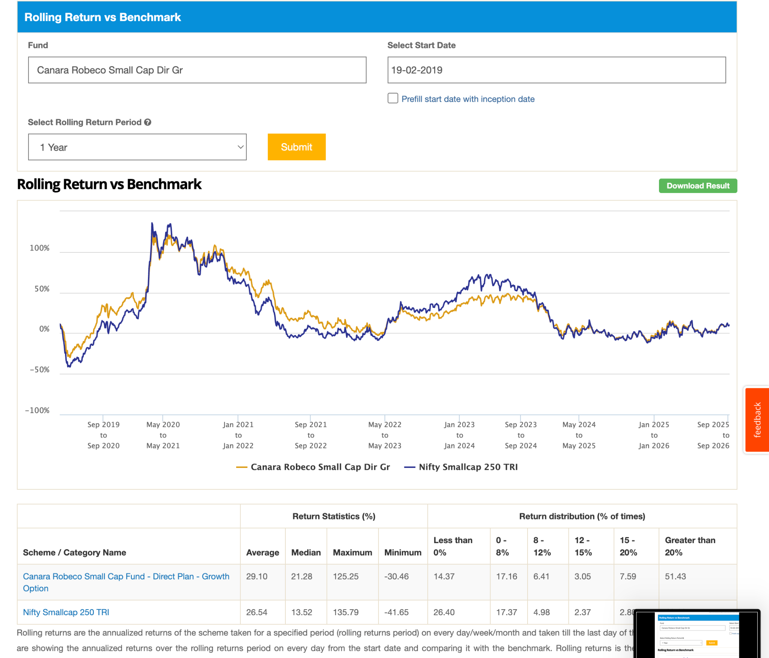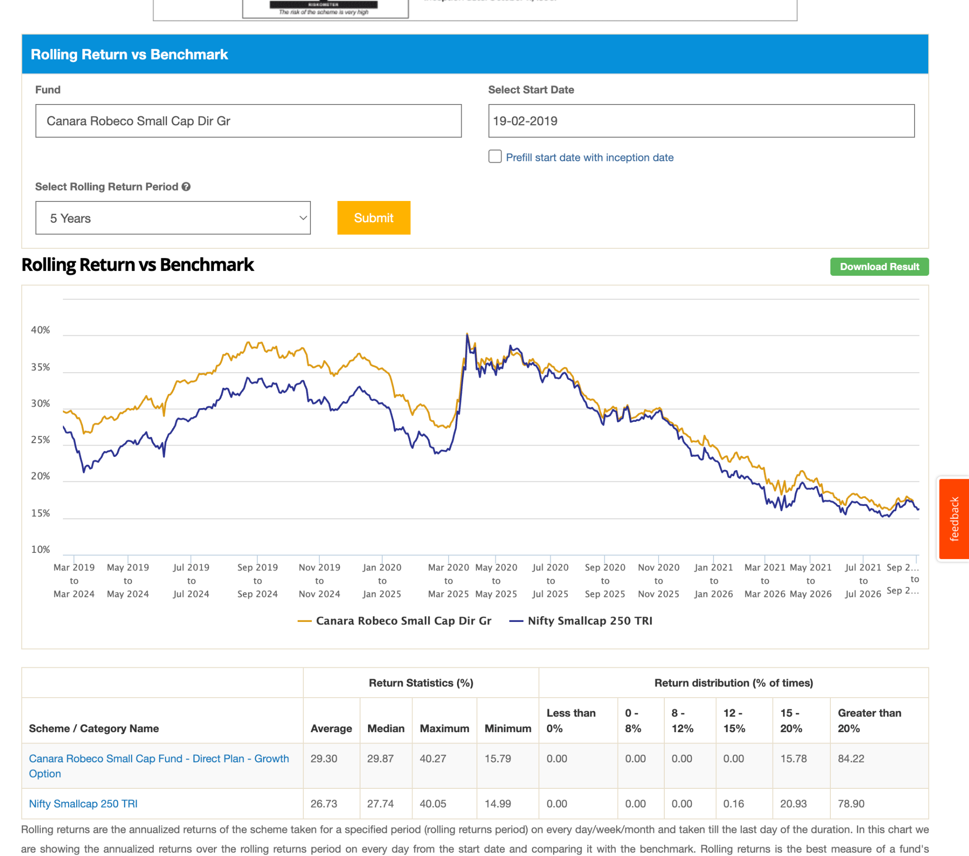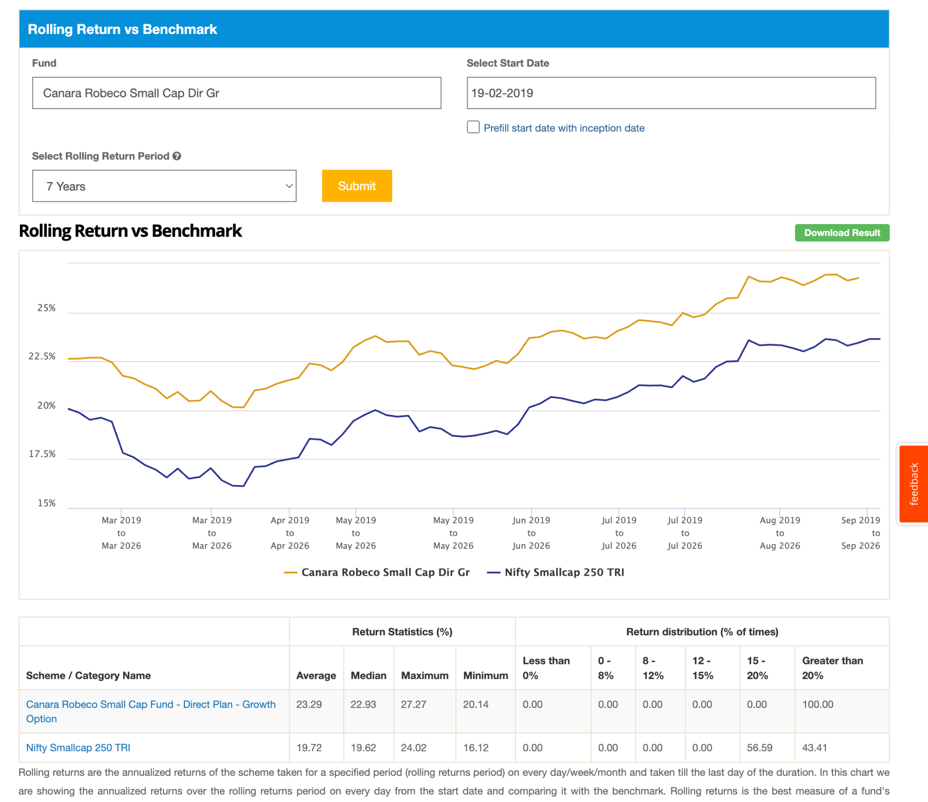
4. DSP Small Cap Dir-G: 21k, 12y old, 0.81% , -35.84, 10y , 7y beating , 5 year tough bit beat. one pattern i see that last 5year alpha getting reduce not sure corno or sebi, but its not like performing worst. 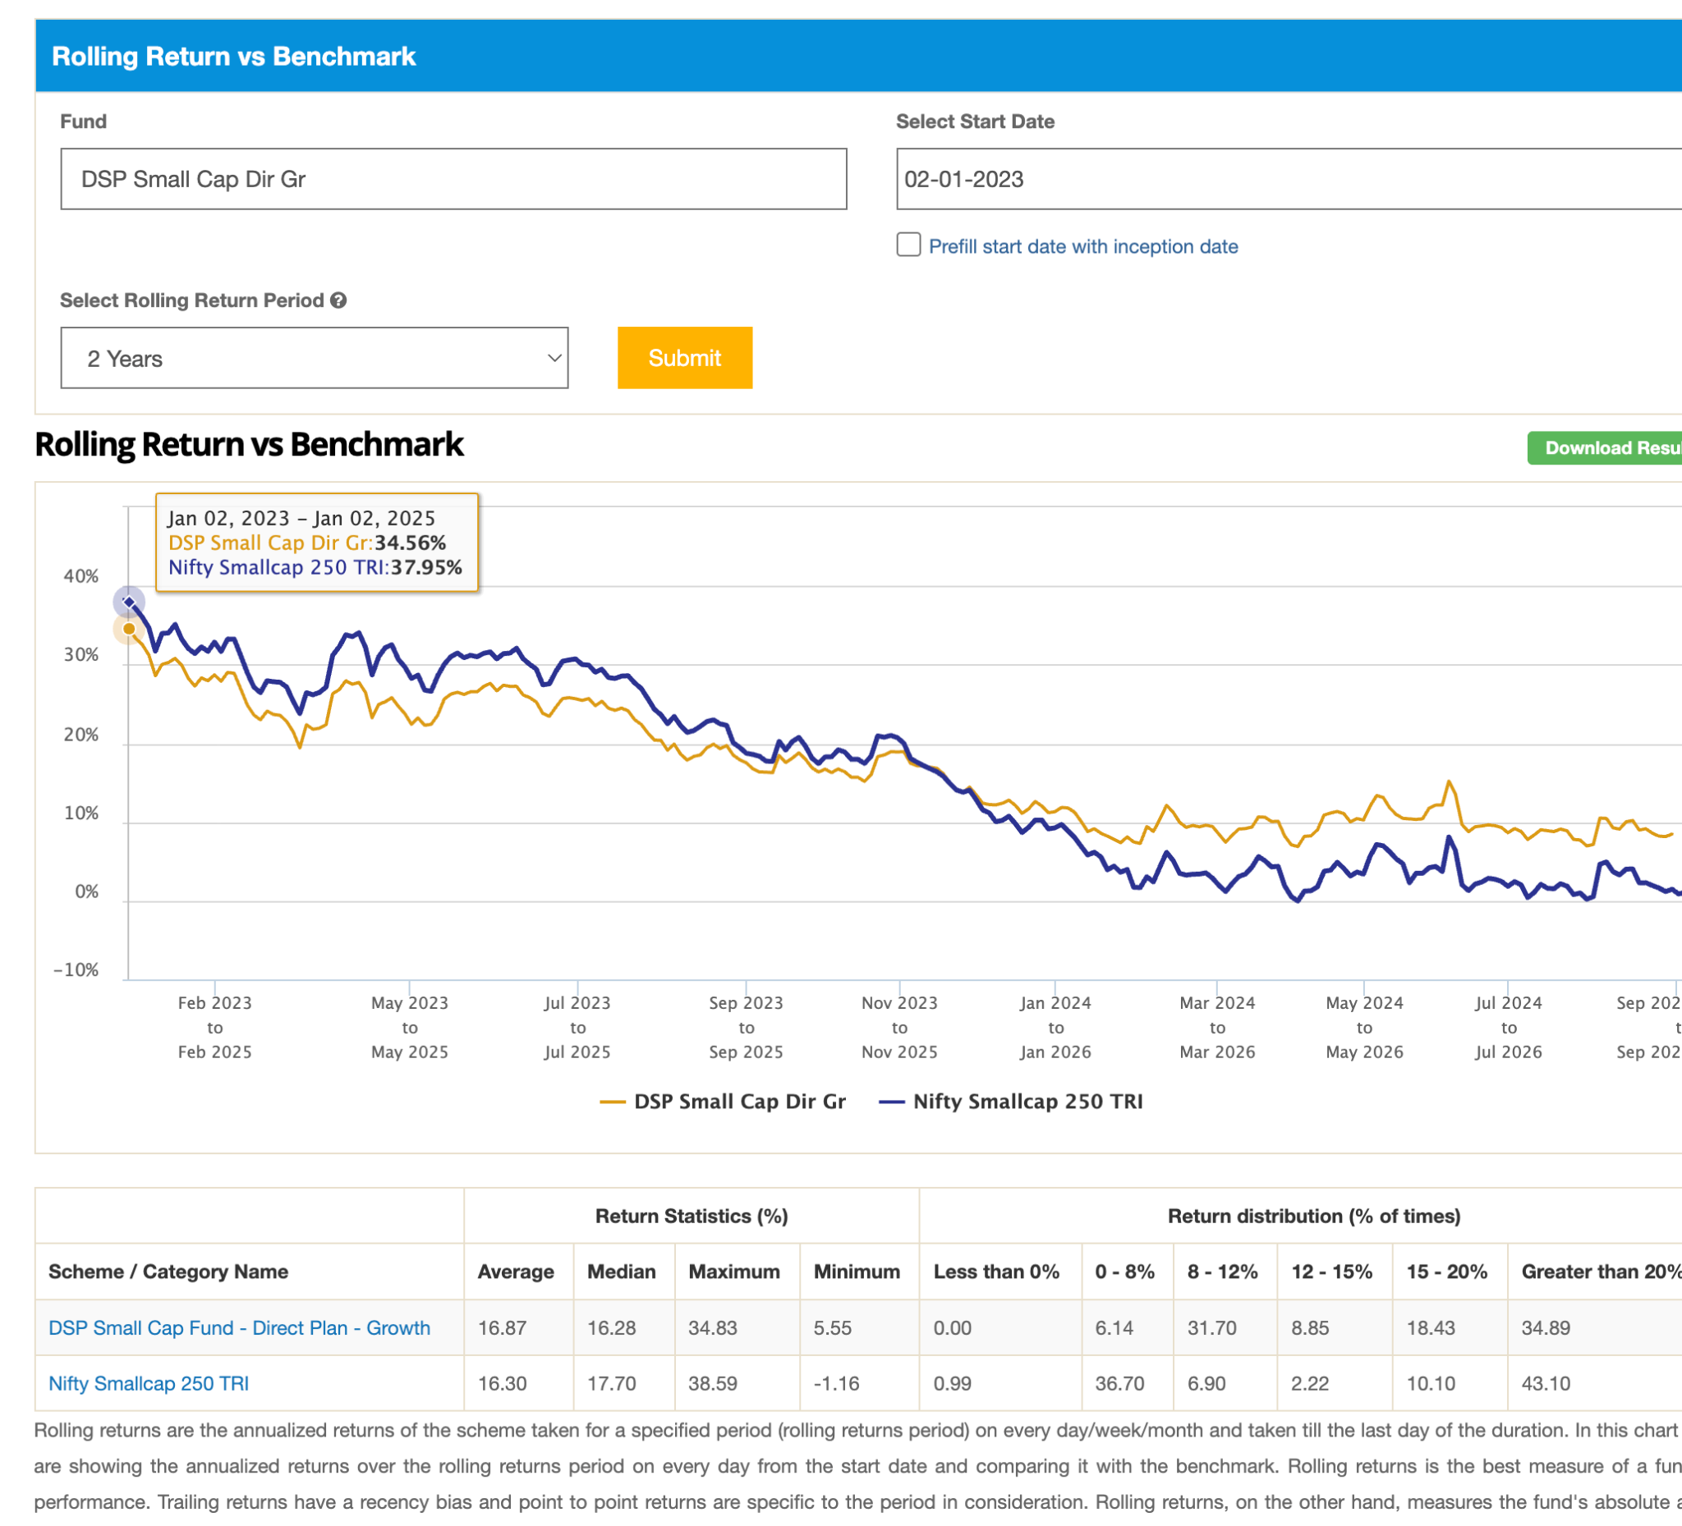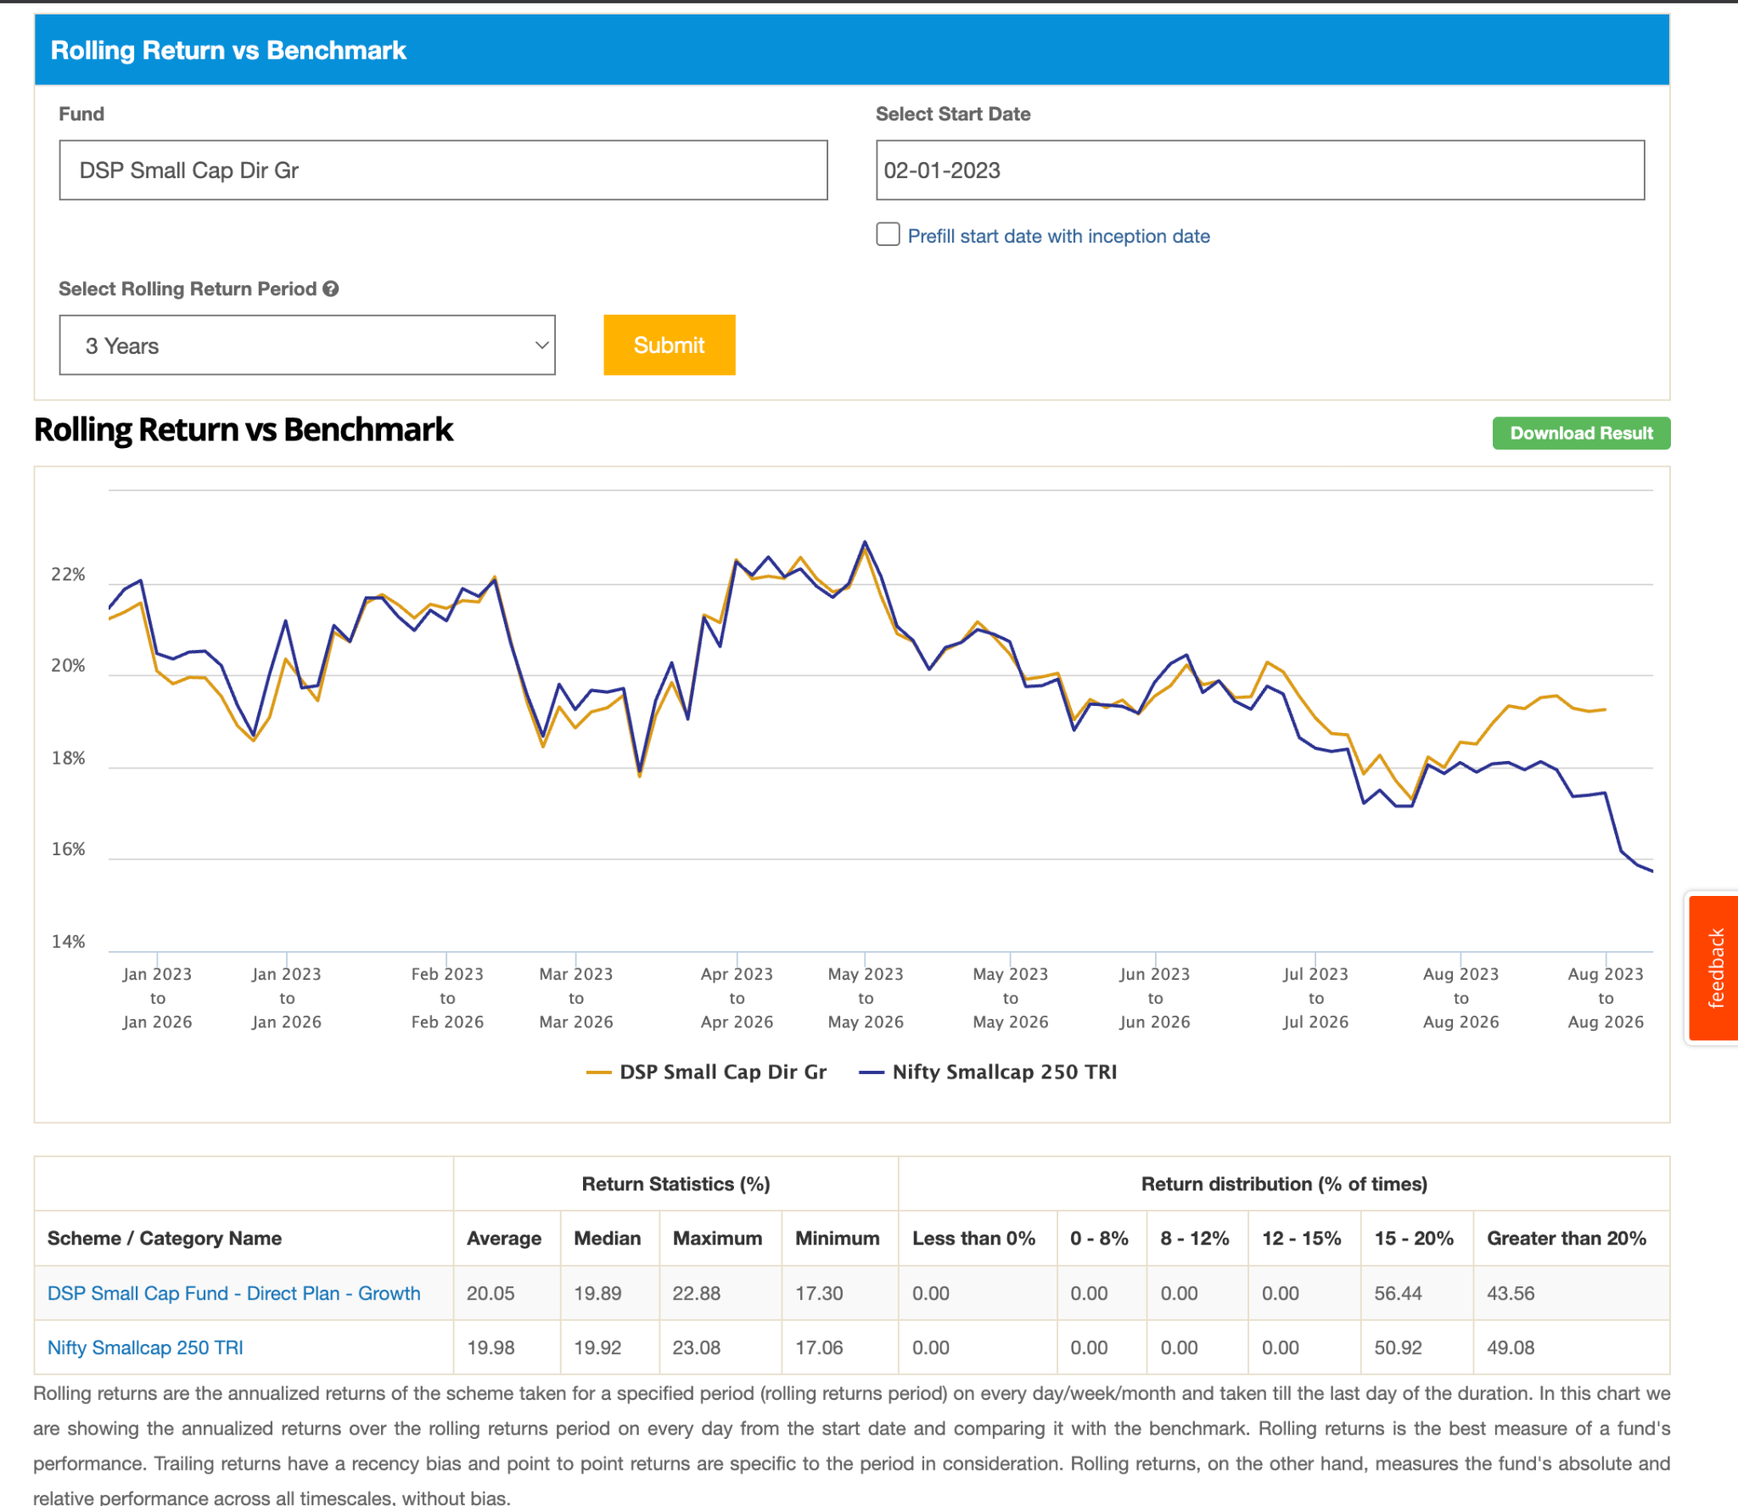
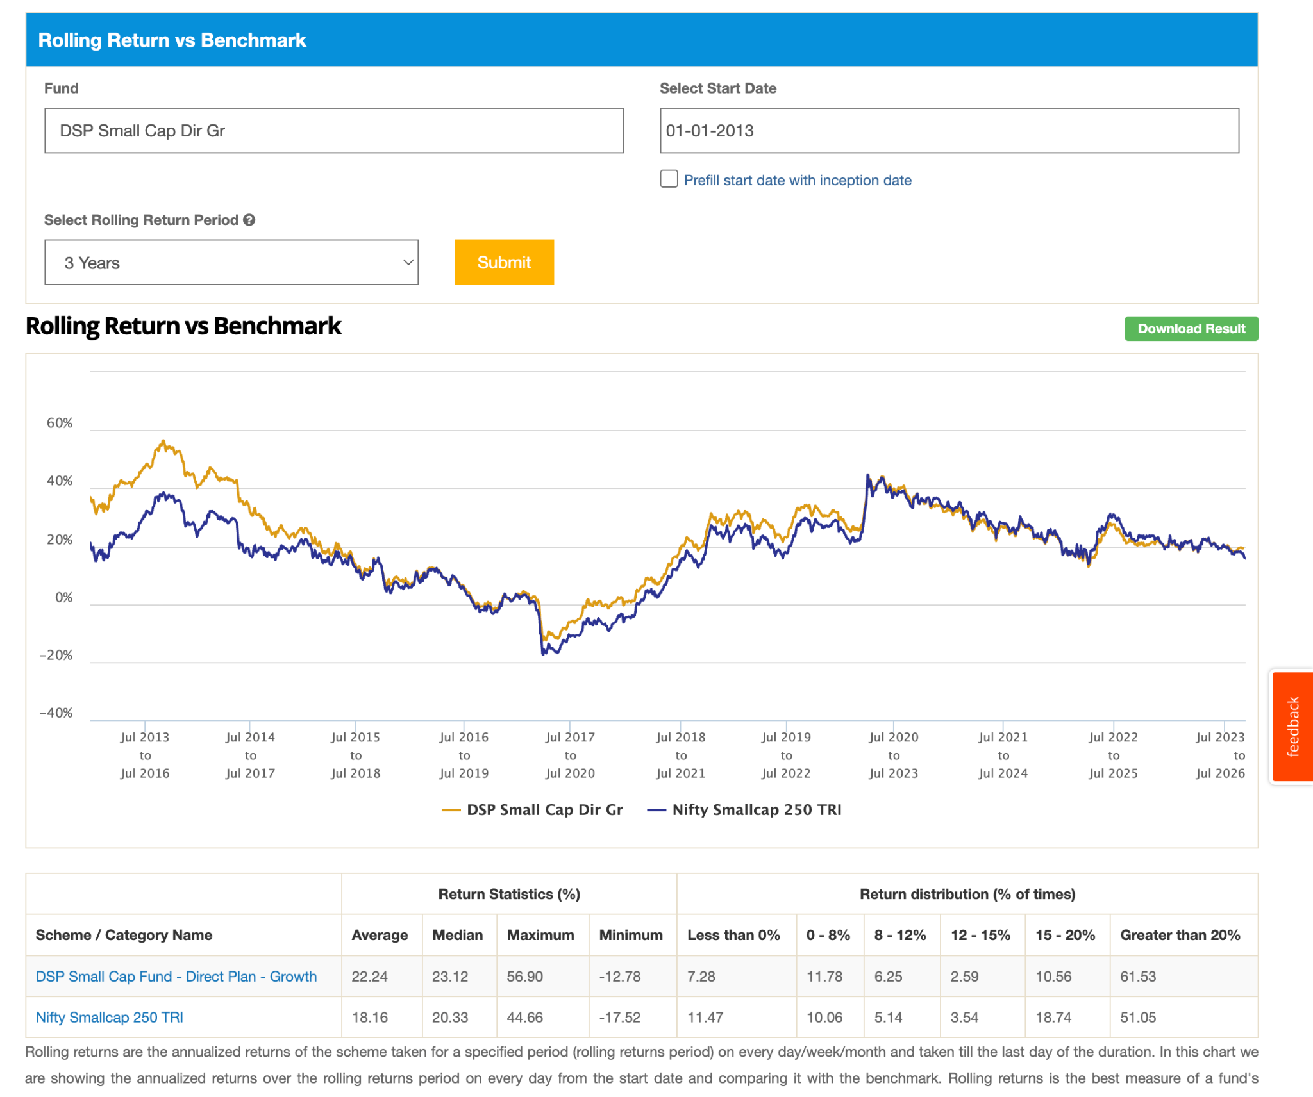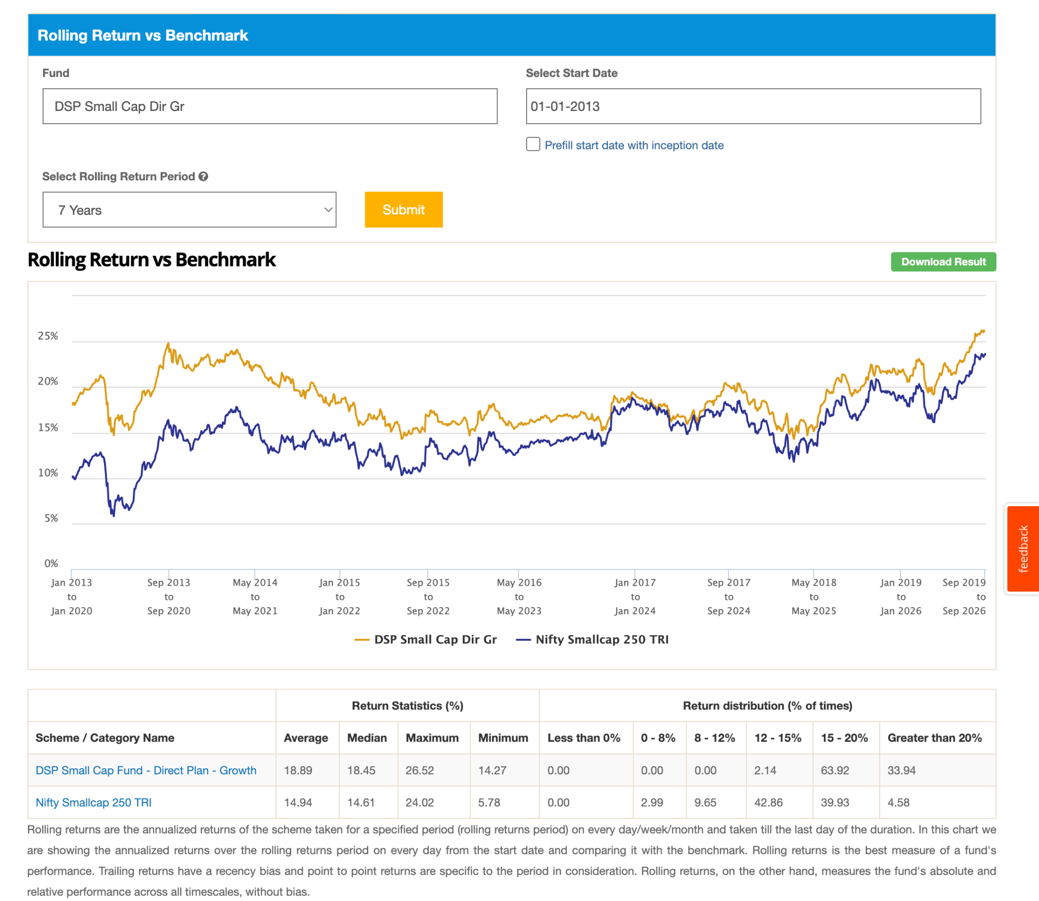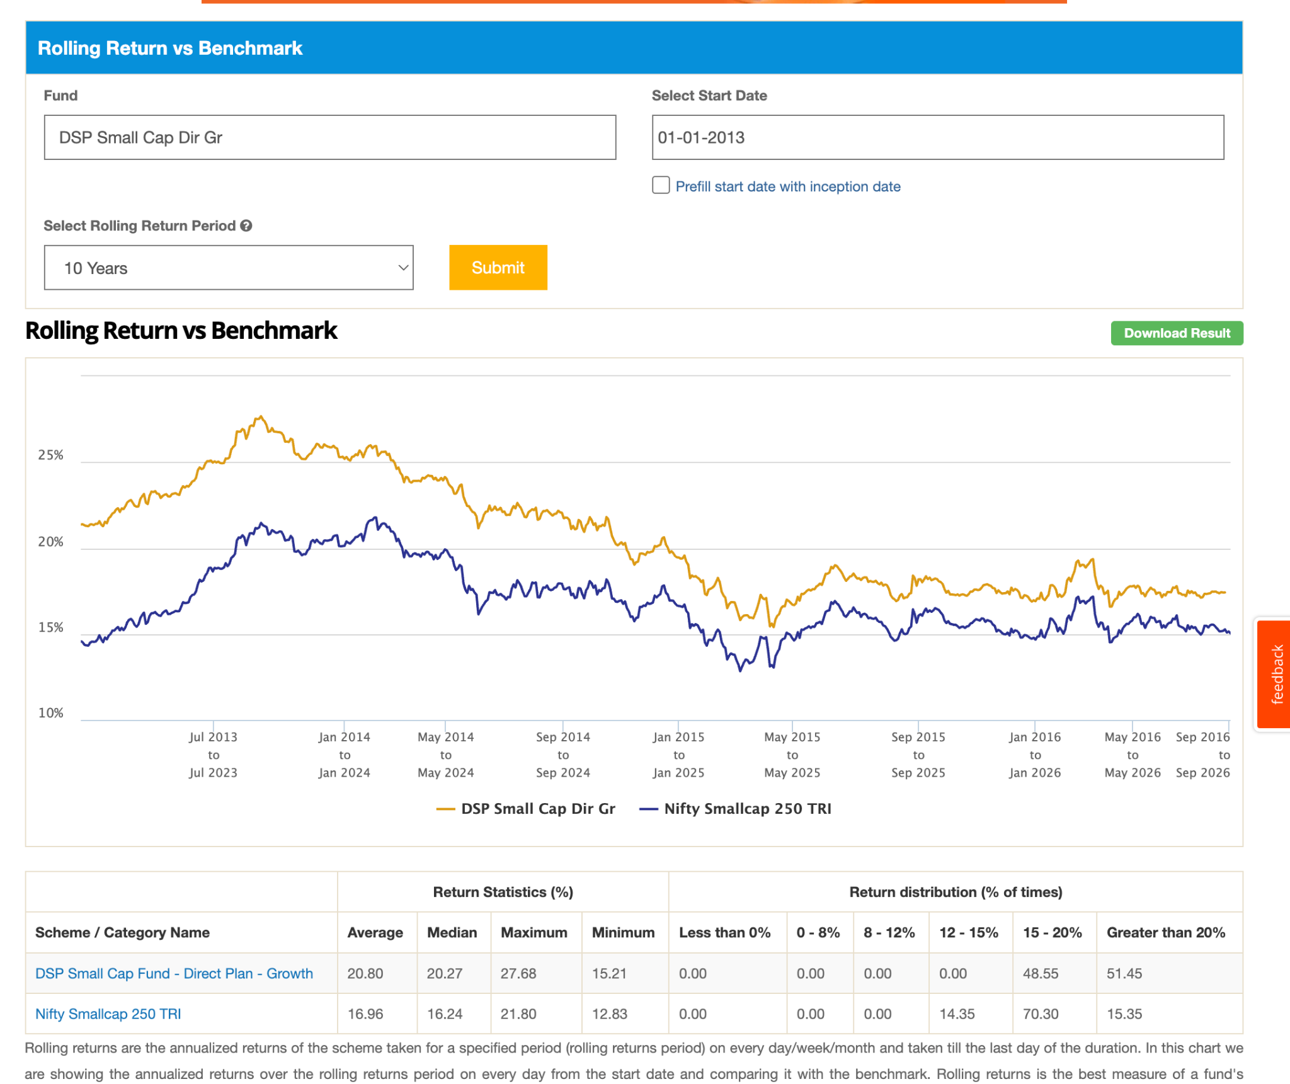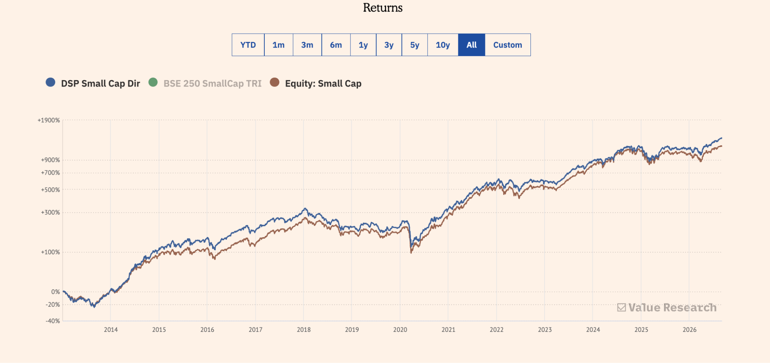
5. HDFC Small Cap Dir-G: 41.6k, 0.75, 12y, -38.15, kind of same patter seems latst 2 y tough ( 7y graph telling that) , doubt is why these funds not wrking as previous in last 3-4 years. check these why happend this. 